

TRIBHUVAN UNIVERSITY

KHWOPA COLLEGE OF ENGINEERING

DEPARTMENT OF CIVIL ENGINEERING

Libali-8, Bhaktapur, Nepal

A
FINAL YEAR PROJECT REPORT ON
“GEOMETRIC DESIGN AND ESTIMATION FOR CAPACITY EXPANSION OF RATOPATI-KALAMASHI ROAD TO DOUBLE LANE STANDARD”

(As a partial fulfillment of BE in Civil Engineering)

PROJECT SUPERVISOR:
Er. Ramesh Bala
Er. Raj Mohan Sijakhwo

PROJECT MEMBERS:
Aaryan Khanal (KCE078BCE003) Aashish Khadka (KCE078BCE005) Bibek BC (KCE078BCE020)
Binod Shrestha (KCE078BCE025)
Navin Kumar Thakur (KCE078BCE047)

DATE:- 2082-12-20

Copyright©

The author has agreed that the library and Department of Civil Engineering of Khwopa College of Engineering, Institute of Engineering (IOE), Tribhuvan University (TU) may make this dissertation freely available for inspection. Moreover, the authors have agreed that the permission for extensive copying of this project report for scholarly purpose may be granted by the supervisors, who supervised the project work recorded herein or, in their absence, by the Head of the Department, wherein this project was done. It is understood that the recognition will be given to the authors of this project, and the Department of Civil Engineering, Khwopa College of Engineering in any use of the material of this work. Copying or publication or other use of this project report for financial gain without approval of the Department of Civil Engineering, Khwopa College of Engineering and author’s written permission is prohibited.
Request for permission to copy or to make any use of the material in this dissertation in whole or part should be addressed to:

Head of Department,
Department of Civil Engineering
Khwopa College of Engineering
Libali-8, Bhaktapur

CERTIFICATE

The undersigned certify that they have evaluated the project work report entitled [“GEOMERTY DESIGN AND ESTIMATION FOR CAPACITY EXPANSION OF RATO PATI – KALAMASHI ROAD TO DOUBLE LANE STANDARD”] submitted by [AARYAN KHANAL, AASHISH KHADKA, BIBEK BC, BINOD SHRESTHA, NAVIN KUMAR THAKUR] and have external oral presentation for the partial fulfillment of the requirement for the degree of Bachelors of Civil Engineering and recommended to the IOE for acceptance of this report.

«External examiner name»,

(Asst. Prof. Dr. Pradeep Kumar Shrestha)
External Examiner

«Supervisor Name», «Supervisor Name»

( Er. Ramesh Bala ) ( Er. Raj Mohan Sijakhwo )
Internal Examiner Internal Examiner

ACKNOWLEDGEMENT

We sincerely extend our gratitude to Tribhuvan University for incorporating this project work into the Bachelor of Civil Engineering curriculum. This initiative has been highly effective in enhancing our practical knowledge, skills, and interest in the subject. Such project work has provided us with valuable opportunities to gain hands-on experience in collecting, processing, and analyzing information, drawing conclusions, and deepening our understanding of a specific topic.
The successful completion of our project, entitled “Geometric Design and Estimation for Capacity Expansion of Ratopati–Kalamashi Road to Double Lane Standard”, would not have been possible without the contribution of many individuals, both directly and indirectly, to whom we express our heartfelt thanks.
We are especially grateful to our supervisors, Er. Ramesh Bala and Er. Raj Mohan Sijakhwo, for their continuous guidance, valuable insights, and dedicated time throughout the course of this work. Our sincere thanks also go to the Survey Department of Khwopa College of Engineering for providing us with the necessary surveying instruments promptly and adequately.
We would like to acknowledge the cooperation and assistance of the local residents during our survey work and data collection.
Finally, we express our deepest appreciation to our friends and all others who extended their support, directly or indirectly, enabling us to successfully complete this project.

ABSTRACT

The project “Geometric Design and Estimation for Capacity Expansion of Ratopati–Kalamashi Road to Double Lane Standard” focuses on the design and construction of a double-lane roadway extending from Ratopati to the Kalamashi bus park, connecting to the kavre Jilla and Nagarkot area a prominent tourist destination.To achieve this, a detailed topographic survey was carried out using Total Station and DGPS equipment. The collected survey data was used to prepare a topographic map in SW Road. Pavement design was conducted in accordance with SP-72 guidelines, based on results obtained from the CBR test performed in the laboratory. The plan and profile of the road were developed in SW Road, along with cross-sections at 20 m intervals, incorporating necessary retaining structures and drainage facilities where required. Finally, quantity calculations and cost estimation were completed to determine the resources needed for successful implementation of the proposed project.

SALIENT FEATURES

1. Name of the Project | Geometric Design and Estimation for Capacity Expansion of Ratopati-Kalamashi Road to Double Lane Standard
- Location  - Nearest Access:  - Province:  - District:  - Latitude:  - Longitude: | Ratopati Ganesh Temple  Bagmati  Bhaktapur 27°40'53"N  85°27'40" E
- Geographical Feature  - Climate:  - Soil:  - Terrain:  - Hydrology: | Tropical, mild  Disintegrated rock  Rolling  Rain fed catchment
- Road Category  - Classification:  - Surface: | Feeder (Class IV) Bitumen
- Alignment  - Starting Point:  - Ending Point:  - Length: | Ratopati Ganesh Temple  At 6+ 989.036 m (Kalamashi Buspark)  6.99 km
- Design Criteria  - Design Speed:  - Gradient:  - Minimum radius of horizontal curve: | 30 km/hr.  10 %  20 m
- Cross – section:  - Right of Way:  - Road Width:  - Carriageway width:  - Side drain: | 30 m  8.5 m  7 m  Drain type G and F
8. Cross Drainage Structure: | 11 Pipe Culvert (90 cm diameter)  1 Causeway
- Retaining Wall  - Masonry Retaining Wall: | 13175.02 m³

- Earthwork  - Cutting:  - Filling: | 67322.49 m³  17819.45 m³
- Traffic  - Traffic Growth Rate:  - Design Period:  - Construction Period:  - Road marking: | 5 % per annum  15 years  2 years  1514.807 m2
- Carriageway:  - Pavement:  - Sub base:  - Base:  - Capping: | 2742.178 m3  9292.23 m3  12339.8 m3  6436.167 m3
13. Total Cost of Project with  contingencies and VAT: | Rs. 705,703,089.31
14. Cost of road per km with contingencies  and VAT: | Rs. 86,232,756.90

CONTENTS

COPYRIGHTS… i
CERTIFICATE… ii
ACKNOWLEDGEMENT iii
ABSTRACT ..iv
SALIENT FEATURES v
LIST OF FIGURES x
LIST OF TABLES xi
LIST OF ABBREVIATION xii
INTRODUCTION 1
  - Project Background 1
  - Objectives 2
  - Scopes of the Study 2
  - General Introduction of Project Area 3
    - Location and Access 3
    - Topographical Region 3
    - Geo-physical 3
    - Geology 4
    - Soil 5
    - Hydrology and Meteorology 5
    - Demographic Characteristics 6
  - Working Approach and Methodology 6
    - Review of Literature 6
    - Data Collection 6
    - Data Processing and Analysis 7
    - Report Submission 7
LITERATURE REVIEW 8
  - NRS 2070 Road Classification 8
    - Administrative Classification 8
    - Technical Classification 9
  - Highway Alignment 10
  - Engineering Survey 10
    - Open Traverse Surveying 10

    - Global Positioning System (GPS) 10
    - Total Station 11
  - Geometric Design of Highway 12
  - Design Speed 13
  - Cross-sectional elements 13
    - Camber 13
    - Width of Pavement or Carriageway 13
    - Road Margin 14
    - Right of Way (ROW) 15
  - Sight Distance 15
    - Stopping sight distance 15
    - Safe overtaking sight distance 16
  - Horizontal Alignment 16
    - Horizontal Curve 16
  - Hairpin Bend 19
  - Vertical Alignment 19
  - Gradient 23
    - Ruling Gradient 23
    - Limiting Gradient 23
    - Exceptional Gradient 23
    - Average Gradient 23
    - Floating Gradient 23
    - Minimum Gradient 23
  - Grade Compensation at Curve 24
  - Side Slope 24
  - Pavements 25
  - Double Bituminous Surface Treatment (DBST) 29
  - Single Bituminous Surface Treatment (SBST) 30
  - Highway drainage 30
  - Retaining Structure 33
METHODOLOGY 35
  - Map Study 35
  - Reconnaissance 35
  - Topographic Survey 35
  - Office Works 35
  - Software for Design 35
    - SW-DTM 36
    - AutoCAD 36
    - SW Road 36
DETAIL ENGINEERING DESIGN 39
  - Adopted Design Standard and Parameters 39
  - Horizontal Alignment 39
    - Horizontal Curvature 39
    - Minimum Radius of Horizontal Curve 39
    - Extra Widening 40
  - Vertical Alignment 41
  - Super Elevation 41
  - Drainage System 41
    - Road Side Drain 41
    - Cross Drains 42
  - Retaining Structures 42
PAVEMENT DESIGN 44
  - Method of Flexible Pavement Design 44
  - IRC SP:72 44
  - Design catalogue 45
  - Determination of future traffic 47
LABORATORY TEST 50
  - California Bearing Ratio (CBR) 50
  - Determination of CBR value 51
PROJECT COST ESTIMATE 53
  - Quantity Estimate 53
  - Rate Analysis 54
  - Abstract of Estimated Cost 56
RESULT 58
DISCUSSION AND CONCLUSION 59
REFERENCES 61
LIST OF ANNEXES…………………………………………………………………………………...62

Figure 1: Route overview(via,Google earth) 1
Figure 2: Geographical location of Bhaktapur District 4
Figure 3: Working of GPS 11
Figure 4: Working of Total Station 12
Figure 5: Cross section of road 14
Figure 6: Horizontal Curve 17
Figure 7: Extra Widening 18
Figure 8: Vertical Curve on Road 20
Figure 9: Valley Curve 21
Figure 10: Summit Curve 22
Figure 11: Load transfer in granular structure 25
Figure 12: Typical cross section of a flexible pavement 27
Figure 13: Typical cross section of rigid pavement 28
Figure 14: Side Gutter 31
Figure 15: Catch Water Drain 31
Figure 16: Catch Water Drain 32
Figure 17: Gabion Retaining Wall 33
Figure 18: Masonry Retaining Wall 34
Figure 19: Masonry retaining structure of chainage 1+000m 34
Figure 20: Plan of road alignment 37
Figure 21: Cross Section of Road at Chainage 1+200 m 38
Figure 22: Profile of road alignment from chainage 0+000 to 0+300 m 38
Figure 23: Dimention of Drain type-F 41
Figure 24: Dimention of Drain type-G 41
Figure 25: Pavement Design Catalogues for Gravel/Granular Bases and Sub-bases........45
Figure 26: Pie Chart of Abstract of Cost 57

Table 1: General Introduction of Project Area 6
Table 2: Correlation between administrative and functional classification 9
Table 3: Terrain Classification 9
Table 4: Design Speeds (km/hr.) 13
Table 5: Camber for various types of road 13
Table 6: Width of Carriageway (m) 14
Table 7: Right of Way 15
Table 8: Stopping Distance 15
Table 9: Overtaking Distance 16
Table 10: Recommended value of super elevation 19
Table 11: Design Parameters for Hairpin Bend 19
Table 12: Embankment Side Slopes 24
Table 13: Cuttings side slopes 24
Table 14: Adopted Design Standard and Parameters 39
Table 15: For Drain F…………………………………………………………………………… 42
Table 16: For Drain G…………………………………………………………………………… 42
Table 17: Traffic category for cumulative ESAL application…………………………………….45
Table 18: Determination of average weight of test vehicles 46
Table 19: Capacity of roads pcu/day…………………………………………………………..….46
Table 20: Standard Load for Various Penetration Values 50
Table 21: California Chart for Determination of Load 50
Table 22: CBR values from testing of sample…………………………………………………….51
Table 23: Classification of CBR above and below 5 %..................................................................51
Table 24: Distribution of CBR according to test done considering homogeneity in sections 52
Table 25: Abstract of Quantity 53
Table 26: Summary of Rate Analysis 55
Table 27: Abstract of Estimated Cost 56

LIST OF ABBREVIATION

ADT | Average Daily Traffic
BC | Beginning of Curve
BM | Bench Mark
BMS | Boulder Mixed Soil
BVC | Beginning of Vertical Curve
CH | Chainage
DOLIDAR | Department of Local Infrastructure Development and Agriculture
DOR | Department of Roads
EC | End of Curve
HPVC | Highest Point on Vertical Curve
IP | Intersection Point
LC | Length of Curve
LPVC | Lowest Point on Vertical Curve
LRN | Local Road Network
MC | Mid of Curve
MT | Metric ton
NRS | Nepal Road Standard
NRs | Nepalese Rupees
PCU | Per Car Unit
R | Radius of Curve
Rm | Running meter
SRN | Strategic Road Network
VAT | Value Added Tax
RER | Road Edge Right
REL | Road Edge Left
BM | Benchmark
Km/hr. Or kmph | Kilometer per hour
CL | Center Line
GP | Ground Point

Project Background
.
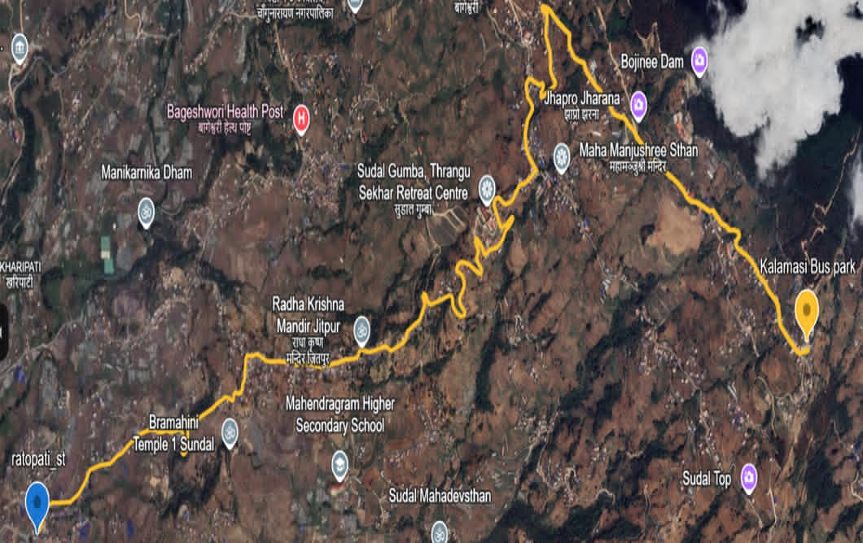

Figure 1: Route overview (via; Google Earth)

Transportation network is one of the most important infrastructural elements for socioeconomic and tourism development of a nation. While talking about the important components of transportation network, road network is the most widely reached component of the national transportation network. It is safer and economic in several conditions. Hence it is very important for a nation to extend the road network as wide as possible for smoothness of infrastructure development. The road connecting Ratopati to Kalamasi Bus Park is an important local access corridor in eastern Bhaktapur. It provides daily connectivity for nearby settlements to local markets, schools, public services, and the bus park. The project starting point at Ratopati lies at approximately 27°40′53″ N and 85°27′40″ E, which places the route in the eastern hilly fringe of Bhaktapur District, where terrain becomes moderately undulating and slope-controlled.
At present, the corridor mainly functions as a narrow intermediate road on average. Field conditions along this route show limited carriageway width, constrained horizontal curvature, and localized roadside development. Because of the moderately hilly topography, drainage concentration during monsoon, slope cutting, and restricted widening space create practical engineering difficulties. These conditions affect traffic operation, road safety, and long-term maintenance performance. The road is important because it acts as a feeder link between interior residential areas and the local transport node at Kalamasi. With increasing population, land development, and daily vehicle movement, the existing single-lane geometry is becoming insufficient for smooth two-way traffic flow. Delays at narrow sections, difficulty in vehicle passing, and reduced safety at bends make geometric improvement necessary. Therefore, this study focuses on detailed engineering survey and geometric design of the Ratopati-Kalamasi road for capacity expansion to double-lane standard. The study will provide the technical basis for alignment improvement, road widening, drainage planning, and safer transportation infrastructure suited to the actual terrain and settlement conditions of the project area.

Objectives
The overall objective of the project is to conduct “GEOMETRIC DESIGN AND ESTIMATION FOR CAPACITY EXPANSION OF RATOPATI-KALAMASHI ROAD TO DOUBLE LANE STANDARD’’

The specific objectives of the study are as follows.
- To conduct detailed field survey of the road/section.
- To design the road profile and cross section along with various components like drainage, retaining structure, etc. as per the standard.
- To prepare the detail estimation of the norms and existing rates.
- To prepare the drawings and report in standard format.

Scopes of the Study
Following works are executed as the part of detail survey and design of the proposed road.
- Reviewing the reports of the alignment survey and choose the economically feasible alignment within the study corridor including geological investigations.
- Conduct a detailed engineering survey of the alignment including the right of way (ROW) strip of the proposed road corridor.
- Establishment of Benchmarks (BMs) and other reference points in the field.
- Taking the longitudinal and cross section at appropriate interval confirming to get the maximum possible profile of the road corridor.
- Geological study of the area confirming nature of rocks, landslides, soil conditions and mass movement.

- Pavement design of the road by determining the appropriate thickness of the pavement using CBR test.
- Preparation of drawings.
- Cost estimation with analysis of rates.
- Preparation of the final report of the project.

General Introduction of Project Area

Location and Access
The final year project was performed at Changunarayan municipality, Bhaktapur. The starting point of the proposed road alignment near Rato Pati mandir and ending point is at kalamashi bus park. The road connects the outer ring road of Kathmandu valley to the tourist area i.e. Nagar Kot, Kavre jilla

Topographical Region
Area road reflects a diverse and complex nature, with variations in slope, elevation, and surrounding landforms. The climate across the section ranges from tropical and sub-tropical in the lower areas to cool to mild temperate conditions in the higher elevations, influenced by altitude and seasonal variations.

Geo-physical
The topography of the Rato Pati to Kalamashi area falls within the diverse and complex terrain of the Bhaktapur district, exhibiting a combination of mid-hill slopes and sections influenced by the Mahabharat range. This section of the Mahabharat range lies between the Churia hills to the south and the low-lying Midland area to the north. The range generally extends east to west, with local breaks where small rivers and streams cut through narrow gorges. The relief varies significantly, with elevations ranging from approximately 180 m to about 700 m above sea level within the corridor. The general gradient in this section averages 200 to 400 m per kilometer, influenced by the watershed catchments draining from the surrounding slopes.
The lower flood-affected areas are characterized by deposits of sand and coarse sediments carried by seasonal streams from the southern slopes. In the higher sections, the terrain is steeper, with limited flat land. Agricultural land is often terraced, reflecting the traditional hill-farming system. River terraces are less prominent due to deep river incisions that leave minimal space for valley cultivation.
In the upper slopes approaching Kalamashi, agriculture is restricted by terrain and altitude, with crops such as maize, millet, and seasonal vegetables cultivated on terraces. Forested areas along the alignment include both mixed hardwood and conifer species. These forests are generally better preserved in the steeper sections and provide slope stability as well as ecological value. Small patches of grazing land are found, and local livestock often utilize these areas seasonally. The varied topography and vegetation indicate a strong link between slope, altitude, and land use patterns along the Rato Pati–Kalamashi corridor.

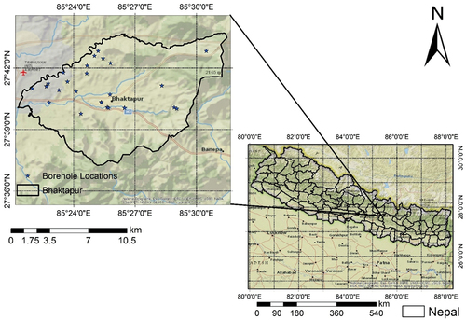

Figure 2: Geographical location of Bhaktapur District

Geology
The geological conditions of Bhaktapur are primarily influenced by its location in the central part of Nepal, which is part of the Himalayan mountain range, Mahabharata range.
The region is geologically complex, with the Himalayan Mountains and the Indo-Gangetic Plains meeting in the region. The district is characterized by a diverse range of geological features, including mountains, hills, valleys, and floodplains. The area is situated in a seismically active zone, with a high risk of earthquakes. The district has experienced several significant earthquakes in the past, including the 1934 Nepal–Bihar earthquake and the 2015 Nepal earthquake, which caused widespread damage and loss of life. The district is also home to several geological formations, including sedimentary rocks, igneous rocks, and metamorphic rocks. The sedimentary rocks are primarily found in the low-lying areas of the district, while the igneous and metamorphic rocks are found in the hilly and mountainous regions. Overall, the geological conditions of Bhaktapur district are complex and varied, with a high risk of seismic activity due to its location in the Himalayan mountain range.
Overall, the geological conditions of Bhaktapur district are complex and varied, with a high risk of seismic activity due to its location in the Himalayan mountain range.

Soil
The nature of soil in Bhaktapur district varies depending on the topography, parent material, and other factors. However, in general, the district's soils are composed of a mixture of alluvium, colluvium, and residual soils.

Alluvial soils are found in areas that have been deposited by rivers and streams. These soils are generally deep, well-drained, and fertile, making them suitable for agriculture. The soils are typically sandy or loamy, and they have a high water-holding capacity.

Colluvial soils are formed by the accumulation of material at the base of slopes due to gravity. These soils are typically shallow, stony, and poorly drained, making them less suitable for agriculture.

Residual soils are formed by the weathering of the underlying rock. These soils are typically found in areas where the bedrock is close to the surface. The soils are generally well-drained and infertile, making them less suitable for agriculture.

In summary, the nature of soil in Bhaktapur district varies depending on the location, but the district is composed of a mixture of alluvial, colluvial, and residual soils. Alluvial soils are generally suitable for agriculture, while colluvial and residual soils are less suitable.

Hydrology and Meteorology
Bhaktapur district has a subtropical climate, with distinct wet and dry seasons. The monsoon season lasts from June to September, with the heaviest rainfall occurring in July and August. The winter season lasts from December to February, with cool and dry weather. The summer season lasts from March to May, with hot and dry weather.

The district is located in the Bagmati River basin, and several rivers and streams flow through the area, including the Hanumante River, the Manohara River, and the Kamala River. The Bagmati River itself is a major river that runs through the Kathmandu Valley,
of which Bhaktapur is a part. The river is an important source of water for irrigation and drinking water for the surrounding population.

The district is also susceptible to floods and landslides, particularly during the monsoon season. In recent years, the area has experienced increased incidents of flash floods and landslides, which have caused significant damage to infrastructure and loss of life.

In terms of meteorology, Bhaktapur district has a network of weather stations that monitor temperature, precipitation, and other meteorological variables. The district experiences significant diurnal temperature variations due to the high elevation, with cooler temperatures at night and warmer temperatures during the day. The average annual temperature in the district is around 19 degrees Celsius.

In summary, Bhaktapur district has a subtropical climate, with distinct wet and dry seasons. The district is located in the Bagmati River basin and is susceptible to floods and landslides, particularly during the monsoon season. The area has a network of weather stations that monitor meteorological variables.

Demographic Characteristics
The alignment lies in the Changunarayan Municipality of Bhaktapur district. The demographic characteristics of this municipality is presented in the table below. The road shall decrease the vehicle operating cost since the passenger or devotees travelling through outer ring road can reach the tourist site in short period of time. The proposed road distance is 6.9 km.

District | Bhaktapur
Municipality | Changunarayan
Population | 55430
Area | 62.98 sq. km
Density | 880 per sq. km
Major Religion | Hinduism
Table 1 General Introduction of Project Area
Source: https://en.m.wikipedia.org/wiki/Changunarayan

Working Approach and Methodology
For the proposed project, we had carried out various desk as well as field works. From beginning to the end, we had worked by coordinating with the supervisors Er. Ramesh Bala and Er Raj Mohan Sijakhwo We were so fortunate to receive his guidance to identify and eliminate the problems and confusions we encountered while going through this project.

The study objectives encompassed mainly four stages of the work.
- Review of literature
- Data collection
- Data processing and analysis
- Report submission

Review of Literature
We, group members gathered as much as information available from written materials, reports, road standard and norms, etc. We also gained knowledge from various internet sites. Some of them are mentioned below.
  - Nepal Road Standard 2070
  - Manual and related books
  - Existing reports, maps and drawings of the project area

Data Collection
  - Vertical Control Data
  - Horizontal Control Data
  - Establishment of Benchmarks
  - Chainage establishment along the alignment, etc.

Data Processing and Analysis
The collected data were processed and analyzed to achieve the required objectives. The processed data helped us to get required drawings, cost estimation and to prepare the report.

Report Submission
For final report, three copies were prepared incorporating the comments and suggestions given by the supervisor and any other rectification.

LITERATURE REVIEW

NRS 2070 Road Classification
According to NRS 2070, roads in Nepal are classified as following.

Administrative Classification
Administrative classification of roads is intended for assigning national importance and level of government responsible for overall management and methods of financing. According to this classification roads are classified into:

- National Highways
National Highways are main roads connecting East to West and North to South of the Nation. These serve directly the greater portion of the longer distance travel, provide consistently higher level of service in terms of travel speeds, and bear the inter- community mobility. These roads shall be the main arterial routes passing through the length and breadth of the country as a whole. They are designated by letter „H‟ followed by a two-digit number.

- Feeder Roads
Feeder roads are important roads of localized nature. These serve the community's wide interest and connect District Headquarters, Major economic centers, Tourism centers to National Highways or other feeder roads. They are designated by letter „F‟ followed by 3-digit number.

- District Roads
District Roads are important roads within a district serving areas of production and markets, and connecting with each other or with the main highways.

- Urban Roads
Urban Roads are the roads serving within the urban municipalities.
In Nepal the overall management of National Highways and Feeder Roads comes within the responsibility of the Department of Roads (DOR). These roads are collectively called Strategic Roads Network (SRN) roads. District Roads and Urban Roads are managed by Department of Local Infrastructure Development and Agricultural Roads (DOLIDAR). These roads are collectively called Local Roads Network (LRN) roads.

Technical Classification
For assigning various geometric and technical parameters for design, roads are categorized into classes as follows:

- Class I
Class I roads are the highest standard roads with divided carriageway and access control (Expressways) with ADT of 20,000 PCU or more in 20 years perspective period. Design speed adopted for design of this class of roads in plain terrain is 120 km/h.

- Class II
Class II roads are those with ADT of 5000-20000 PCU in 20 years perspective period. Design speed adopted for design of this class of roads in plain terrain is 100 km/h.

- Class III
Class III roads are those with ADT of 2000-5000 PCU in 20 years perspective period. Design speed adopted for design of this class of roads in plain terrain is 80 km/h.

- Class IV
Class IV roads are those with ADT of less than 2000 PCU in 20 years perspective period. Design speed adopted for this mountainous terrain is 30 km/hr.

 | Plain and Rolling  Terrain | Mountainous Terrain
National Highways | I, II | II, III
Feeder Roads | II, III | III, IV

Table 2 Correlation between administrative and functional classification
(Source: NRS 2070)

SN | Terrain Type | Percent Cross Slope
1 | Plain | 0-10
2 | Rolling | >10-25
3 | Mountainous | >25-60
4 | Steep | >60

Table 3 Terrain Classification
(Source: NRS 2070)

Highway Alignment
The position of the center line of the highway in the ground is called highway alignment. The projection of highway alignment in horizontal plane is called horizontal alignment and the projection in vertical plane is called vertical plane.

Following are the basic requirements of an ideal highway alignment.
  - The route between any two points should be the shortest route.
  - The alignment should satisfy the safety requirements.
  - The alignment should have easy curves and gradients.
  - The cost of construction should be economic.
  - Vehicle operation should be easy.

Engineering Survey
Surveying is the art of determining the relative position of point on, above or below the surface of the earth by direct or indirect measurement of distance, angle, and elevation.

Open Traverse Surveying
Open Traverse Surveying is a surveying traverse that starts from a station of known or adopted position but does not terminate upon such a station and therefore does not completely enclose a polygon. In this type of survey, the surveying starts from known control points and the coordinates and RL are transferred from the adjacent stations and the obtained coordinates are checked through back sighting. In the survey for road alignment, open traverse survey is conducted and required RL and coordinates in terms of Northings and Eastings are found out.

Global Positioning System (GPS)
The Global Positioning System (GPS) is a satellite-based navigation and surveying system used for the determination o0f precise position and time of a point using radio signals from the satellites. It works based on the principle of Trilateration. Hence, it is primarily a navigation system for real time positioning. It uses satellites, a receiver and algorithms to synchronize locations, velocity and rime data for air, sea and land travel.

GPS was originally developed for military use by US army and employed for civilian use since 1990s. In addition to application of GPS, in mobiles and car navigation systems, surveying was the first commercial adaptation of GPS technology. GPS is used for more accurate boundary and construction surveys.

The satellite system consists of a constellation of 24 satellites in six earth centered orbital planes, each with 4 satellites, orbiting at 20,000 km above earth and travelling at a speed of 14,000 kmph. While we only need 3 satellites to produce a location on earth’s surface, a fourth satellite is often used to validate the information from the other three. The fourth satellite also moves us into the third dimension and allows us to calculate the altitude of the device. GPS is made up of three different components, called segments that work

together to provide location information; space (satellites), ground control and user equipment.
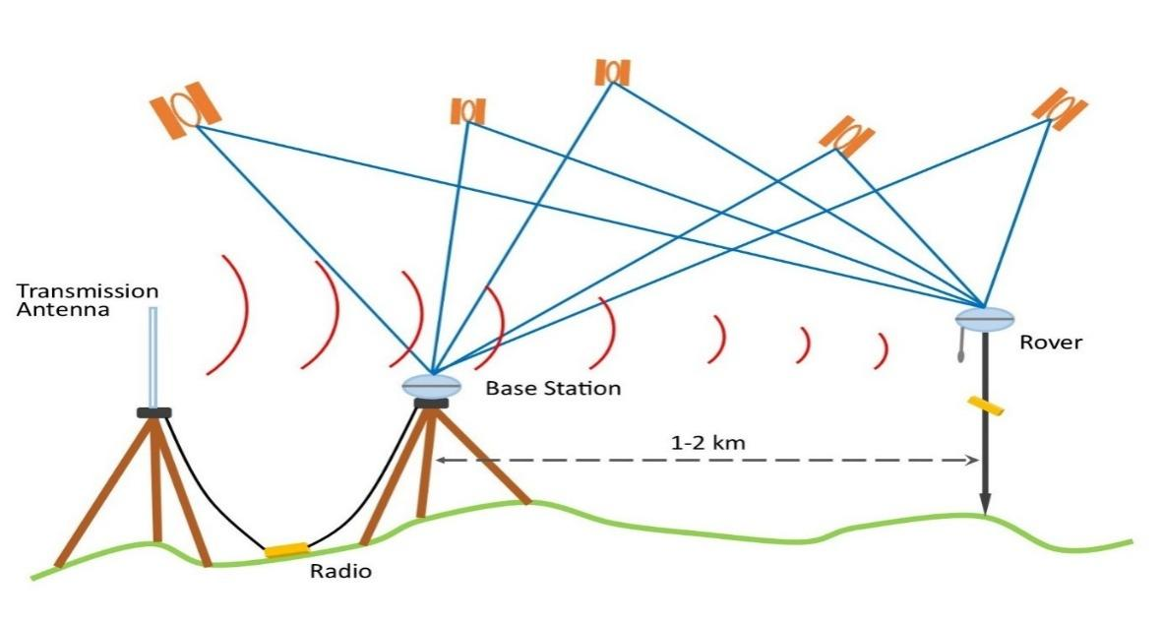

Figure 3 Working of GPS
(Source:https://www.surveyschool.org.uk/wpcontent/uploads/2019/03/GNSS.jpg)

A total station is an electronic theodolite that measures angles and distances between points. It’s the most advanced surveying instrument today, capable of measuring the horizontal and vertical angles to ±3 seconds.

A total station has two associated devices used during surveying: a digital distance meter which measures distance, and an angle sensor or right-angle optical prism, which measures the horizontal or vertical angle.

Like the word “total” means, this instrument can do many measurements; a Total Station is a telescope mounted on wheels or a tripod.

It can measure distances and angles between lines, heights of points on an object, area, volume of an object from its sides, slope angle between two directions on the ground, etc.

The accuracy of a total station is dependent on the type of instrument.
  - Angle accuracy can range from 2” to 5”.
  - Linear accuracy can range from (0.8+1 ppm × D) mm to (3+3 ppm × D) mm, where D is Distance measured.

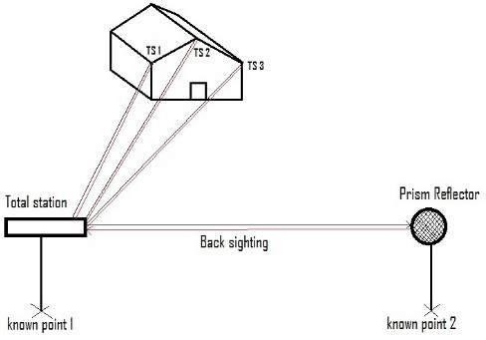
Figure 4 Working of Total Station
(Source: https://www.researchgate.net/figure/11-Principle-of-Total-station_fig4)

Geometric Design of Highway
Geometric design refers to the dimensions and arrangements of the visible features of a roadway. This includes pavement widths, horizontal and vertical alignment, slopes channelization, intersections and other features that can significantly affect the operations, safety and capacity of the roadway network. The geometric design of the roadway should be consistent with the intended functional classification of the highway, and fit the characteristics and needs of all of its users.

A number of factors affect the geometric design of highway. They are as follows:
  - Design speed
  - Topography
  - Environmental factors
  - Traffic factors
  - Economy
  - Design hourly volume and capacity

Following are the elements of geometric design of highway:
  - Horizontal and vertical alignment
  - Longitudinal profile
  - Pavement width
  - Sight distance consideration
  - Gradient
  - Slopes channelization
  - Intersections
  - Hairpin bend details
  - Cross-sectional elements

Design Speed
Overall geometric design of a road is a function of design speed. Design speed is decided based on the importance of the road (road class) and the type of terrain. The design speed to be adopted for various classes of roads is given in table below:

Road Class | Plain | Rolling | Mountainous | Steep
I | 120 | 100 | 80 | 60
II | 100 | 80 | 60 | 40
III | 80 | 60 | 40 | 30
IV | 60 | 40 | 30 | 20
Table 4: Design Speeds (km/hr.)
(Source: NRS 2070)

Design speed should be the guiding criterion for geometric design of the road. But in very difficult terrains and unavoidable circumstances design speed can be reduced to 75% of the values given on the table above.

Cross-sectional elements
Following are the elements of cross-section of highway:
  - Cross-slopes or camber
  - Pavement width
  - Kerb
  - Road margins
  - Formation width
  - Right of Way

Camber
All straight sections of roads shall have a camber or cross-fall as stated in NRS 2070. The purpose of camber is to drain out the water that may affect the structure of highway.

Pavement type | Cement  Concrete | Bituminous | Gravel | Earthen
Camber (%) | 1.5 to 2 | 2.5 | 4 | 5

Table 5 Camber for various types of roads
(Source: NRS 2070)

Width of Pavement or Carriageway
A carriageway consists of the width of the road on which the vehicle is not restricted by any physical barriers or separation to move laterally. A carriageway generally consists of

a number of traffic lanes together with any associated shoulder, but maybe a soul lane in width.
For a single lane road;
Width of a vehicle = 2.5 m Clearance on either side = 0.625 m Total width = 3.75 m

For two-lane road;

Width of two vehicle = 2.5 × 2 = 5 m Clearance on either side = 0.5 m Central clearance = 1 m
Total width of road = 7 m

Single lane road | Intermediate lane | Multi-lane pavements width  per lane
3.75 (up to 3m in difficult  terrain) | 5.5 | 3.5

Table 6 Width of Carriageway (m)
(Source: NRS 2070)

Road Margin
The various elements of in the road margin are the shoulder, separator if any, and the shoulder excluding side drains, driveway, cycle track, footpath, guard rail and embankment slope.
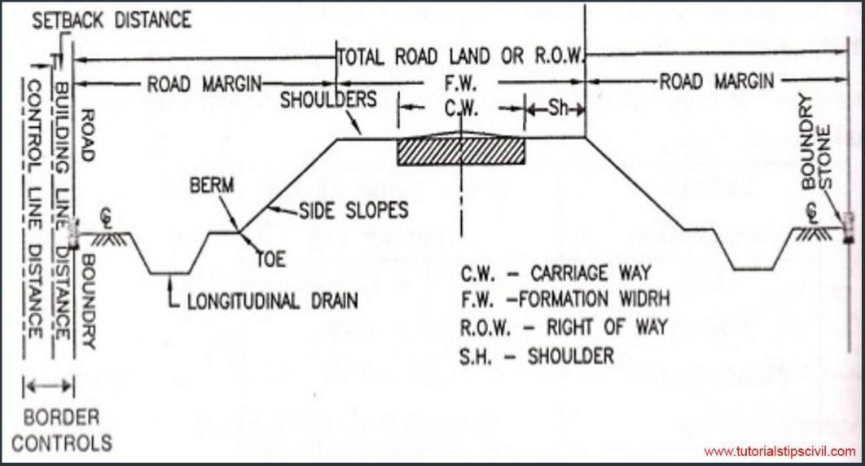
Figure 5 Cross section of road
(Source: https://tutorialstipscivil.com/civil-topics)

Right of Way (ROW)
Right of way is the total land area acquired for the construction of the roadway. Its width should be enough to accommodate all the elements of the roadway cross section, any future widening of the road and any public utility facilities that will be installed along the roadway. ROW is the area of the road acquired for carriages way + other necessities + future extension, along its alignment. Good practice is to acquire ROW wide enough to accommodate the ultimate development and all components of the road.

Road Type | Total Right of Way (m)
Highways | 50
Feeder Roads | 30
District Roads | 20

Sight Distance
Table 7 Right of Way

(Source: NRS 2070)

For safety it is necessary that sight distance of adequate length should be available to permit drivers enough time and distance to control their vehicles. Sight distances are usually governed by the distance required for stopping (stopping distance) and overtaking (overtaking distance). Three types of sight distance are considered while designing a highway.
- Stopping sight distance
- Safe Overtaking sight distance
- Safe sight distance for entering into controlled intersection

Stopping sight distance
Stopping distance is the distance ahead needed by a driver to bring his vehicle to a complete stop before meeting a stationary object in his path. Stopping distance for various speeds are given in table below.

Speed (km/hr.) | 20 | 30 | 40 | 60 | 80 | 100 | 120
Stopping Distance  (m) | 20 | 30 | 50 | 80 | 130 | 190 | 260

Table 8 Stopping Distance
(Source: NRS 2070)

Stopping Distance = Lag Distance + Braking Distance SD (m) = v t + v²/ (2gf)
Were,
v = speed of vehicle in m/s
f = design friction coefficient (0.4 to 0.35 for 30 to 80 kmph) t = reaction time in second

Safe overtaking sight distance
Overtaking distance is the minimum distance that should be available to the driver to overtake another vehicle safely. Overtaking distances for various design speeds are given in the table below.

Speed (kmph) | 40 | 60 | 80 | 100 | 120
Minimum Overtaking Distance (m) | 185 | 300 | 470 | 640 | 880
Table 9: Overtaking Distance
(Source: NRS 2070)

Horizontal Alignment
The horizontal alignment is the route of the road, defined geometrically as a series of horizontal tangents (straight roadway sections), circular curves, and spiral transitions. It shows the proposed roadway location in relation to the existing terrain and adjacent land conditions.

Horizontal Curve
Horizontal curves are those that change the alignment or direction of the road. A horizontal curve provides a transition between two tangent strips of roadway, allowing a vehicle to negotiate a turn at a gradual rate rather than a sharp cut.

Elements of horizontal curve are as follows:
- Tangent length (T): The length between the beginning of the curve or end of the curve and the point of the intersection is called the tangent length. It depends on the deflection angle (∆) and the radius of the curve (R). For a simple circular curve, it is given as: -
T = R × tan (∆/2)

- Length of Curve (L): The length of curve from the point of commencement to the point of tangency is called the length of curve. If the curve is designated by its degree of curvature, the length of curve will depend upon the criteria used for the definition of the degree of curve.
L= R × ∆ in radians

- Length of chord (l): It is the chord joining the point of curve with the point of tangent. l= 2 × R × sin (∆/2)

- Deflection angle: The angle between which a survey line makes with the propagation of the preceding line is called deflection angle. It is measured to the clockwise or anticlockwise from the prolongation of the previous line. Its value ranges from 0 to 180 and denoted by ∆.

- Radius of curve (R): To keep the centrifugal ratio within low limit, the radius of the curve should be kept high for smooth and efficient vehicle operation. According to NRRS 2069, the minimum radius to be adopted is 12.5 for district road.
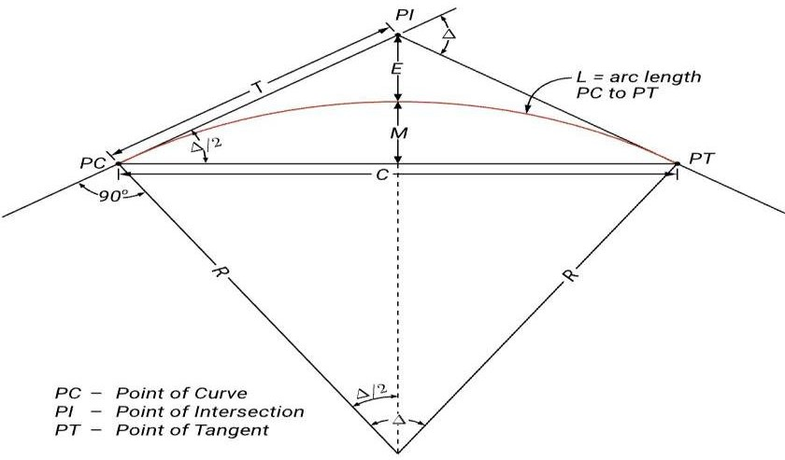

Figure 6: Horizontal Curve
(Source: https://georgexyz.com/geometric-design-equations.html)

- Radius of Horizontal Curve:
For the certain speed of vehicle, the centrifugal force is dependent on the radius of the horizontal curve. To keep the centrifugal ratio within low limit, the radius of the curve should be kept high. The centrifugal force which is counteracted by the super elevation and lateral friction is given by the relation
e + f = v² / (g R)
0.07 + 0.15 = v²/ (g R) (where e = 0.07 is maximum allowable super elevation rate)
0.22 = v²/ (g R) (f = 0.4 is design coefficient of lateral friction)
The ruling minimum radius of the curve for ruling design speed v m/sec or V, km/ h is given by:
Rruling=v² / (e + f) × g Rruling = V2 /127 (e + f) Where,
v and V = design speed in m/sec and km/ hr. respectively. e = super elevation
f= design value of transverse skid resistance g= acceleration due to gravity (m/sec²)

- Extra Widening
Extra widening refers to the additional width of carriageway that required on a curved section of a road over and above that required on a straight alignment.

The vehicle occupies more width that it occupies on straight portion of the road. To compensate this, the carriageway width increased on the entire curved portion of the road, which called extra widening.

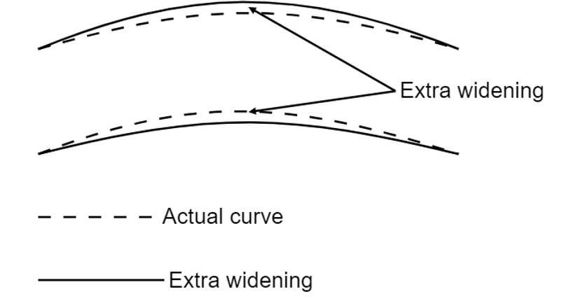
fig 7: Extra Widening
(Source: https://www.kpstructures.in)

This widening is done due to two reasons: -
  - Mechanical Widening
  - Psychological Widening

Mechanical Widening (Wm): The reason for the mechanical widening is that when a vehicle negotiates a horizontal curve, the rear wheels follow a path of shorter radius than the front wheels.
Wm = nl²/2R

Psychological Widening (Wps): Widening of pavements has to be done for some psychological reasons also. There is a tendency for the drivers to drive close to the edges of the pavement on curves.
Some extra space is to be provided for more clearance for the crossing and overtaking operations on curves. IRC proposed an empirical relation for the psychological widening.
Wps = V/9.5√R

Extra Widening = Mechanical Widening + Psychological Widening
= nl²/2R + V/9.5√R Where,
l = length of wheel base generally taken as 6.1 m V= design speed (km/hr.)
R= radius of curve

- Super elevation
Super elevation is the transverse slope provided to counteract the effect of centrifugal force and reduce the tendency of vehicle to overturn and to skid laterally outwards by raising the pavement outer edge with respect to inner edge. Super elevation is represented by “e”.

Design criteria for super elevation are:
  - Super elevation for 75% design speed is calculated neglecting friction. e = (0.75 v)² / g R
e =V² /225R

  - If the calculated e is less than 1/15 or 0.07, then the calculated value is adopted.
  - If the calculated value is more than 0.07 or 1/15, then super elevation equal to
0.07 is provided.
  - Then coefficient of friction is checked for maximum value of e. f = (v² /gR-0.07)
  - If the calculated value of friction coefficient is less than the 0.15, the super elevation is safe for design speed. If not, restricted speed is calculated.

Terrain | Plain & Rolling | Hilly Area (Snow  Bounded) | Hilly Area (not  bounded by snow)
Super Elevation | 7 % | 7 % | 10 %
Table 10: Recommended value of super elevation
(Source: NRS 2070)

Hairpin Bend
A hairpin bend is a bend in a road with a very acute inner angle, making it necessary for an oncoming vehicle to turn about 180 degrees to continue on the road. It is named for its resemblance to a bent metal hairpin. A minimum distance of 60 m should be provided between successive bends of consecutive hairpin bends.

Minimum design speed | 20 km/hr.
Minimum radius of curvature | 15 m
Minimum length of transition curve | 15 m
Maximum longitudinal gradient | 4 %
Maximum super elevation | 10 %
Table 11: Design Parameters for Hairpin Bend
(Source: NRS 2070)

2.10 Vertical Alignment
In the vertical perspective, a roadway is also comprised of tangents which are smoothly connected by curves. For vertical alignment, the tangents represent grades which can either be flat, uphill or downhill.

The typical vertical curve is a symmetric, parabolic curve whose shape is defined by the parabolic equation. The information required to fully define a vertical curve is the elevation of the beginning of the curve, the grades of the two tangents that are connected ad the length of the curve. The naming convention of vertical alignment is similar to horizontal alignment. Several points of interest along the curve include that the location where the tangents intersect, which is known as the Point of Vertical Intersection.

The location where the vehicle leaves the tangent grade and begins to drive along the curve, is known as the point of vertical curvature. The point where the curve ends and the vehicle returns back to the tangent grade is known as the Point of Vertical Tangency.

In general, parabolic curve is preferred as vertical curve in the vertical alignment of roadway for the ease of movement of vehicles. But based on the convexity of curve vertical curves are divided into two types
- Valley curve
- Summit curve

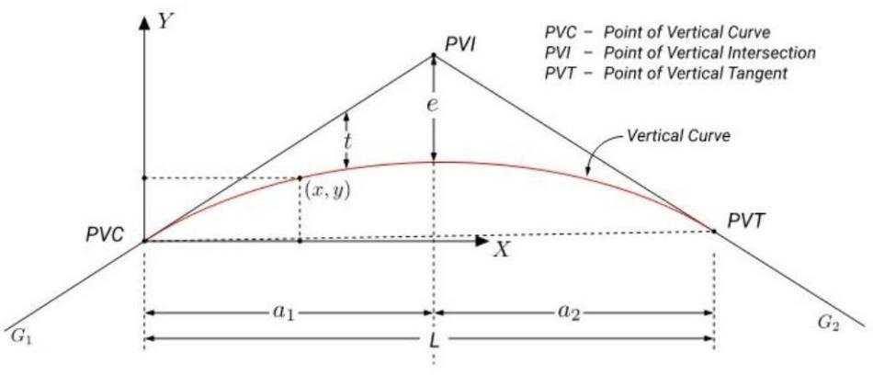
Figure 8: Vertical Curve on Road (Source: https://www.theengineeringcommunity.org/)

Valley Curve (Sag Curve)
Valley curve connects falling gradient with rising gradient so, in this case convexity of curve is generally downwards. It is also called as sag curve.

They are formed when two gradients meet as any of the following four ways:
- When a negative gradient meets another mild negative gradient.
- When a negative gradient meets a level zero gradient.
- When a negative gradient meets with a positive gradient.
- When a positive gradient meets another steeper positive gradient.
The maximum permissible gradient is taken as 12% and maximum average gradient is 8%. During the design sight distance is considered and according to NRS 2070, minimum value of stopping distance is 10m for design speed of 15km/h.
    - For comfort condition L = (NV³/C)^{0.5}
    - Length of valley curve for headlight sight distance
      - L > SSD
L = NS² / (2h + 2S tanα)
      - L < SSD
L = 2S – ((2h + 2S tanα)/N)

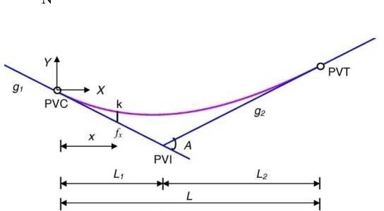
Figure 9: Valley Curve
(Source: https://mathalino.com/tag/reviewer/grade-diagram)

Question: For a portion of the highway, descending gradient 1 in 25 meets ascending gradient 1 in 20. The design speed is given as 90 km/hr. Calculate the length of the valley curve (L) based on comfort and headlight distance criteria. Take S value as 153.66 m. Assume L is greater than SSD. (Source: https://apsed.in/)

Solution:
N = | (±n1) - (±n2) |
= |-1/25 - 1/20| = 0.09
Comfort Criteria:
L = 2 * ((V^3) *N/C) ^ (1/2)
Or L = 2 * (((0.278*90) ^3) * 0.09 / 0.5) ^ (1/2) Or L = 106.066 m
Headlight Distance Criteria:
For L > SSD
L = (N*S^2) / (1.5 + 0.035*S)
= (0.09*153.66^2) / (1.5 + 0.035*153.66)
= 308.96 m
Therefore, the length of the transition curve as per the comfort criterion is 106.66m and as per headlight sight distance is 308.96m. Usually, a higher value is adopted for design.

Summit Curve (Crest Curve)
Summit curve connects rising gradient with falling gradient hence, the curve has its convexity upwards. It is also called as crest curve.

They are formed when two gradients meet as in any of the following four ways:
- When a positive gradient meets another positive gradient.
- When positive gradient meets a flat gradient.
- When an ascending gradient meets a descending gradient.
- When a descending gradient meets another descending gradient.

The maximum value of N adopted is in longitudinal profile 12 % and minimum value of N is 1 %. During design, sight distance is considered and according to NRS 2070, that the headlight sight distance will be stopping sight distance, minimum value of stopping sight distance is 15 m and that the centripetal acceleration will be of 0.3 m/s².
Case (a): when L > SSD
L = NS²/ ((2H)^{0.5} + (2h)^{0.5}))²
Case (b): when L < SSD
L = 2S – ((2H)^{0.5} + (2h)^{0.5})² / N
N = algebraic difference of grade
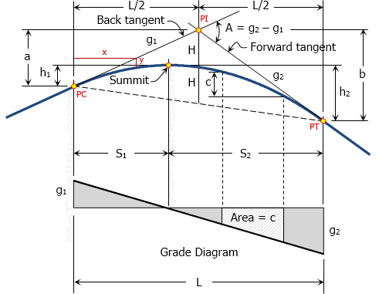

Figure 10: Summit Curve
(Source: https://mathalino.com/tag/reviewer/summit-curve)

Question: Design vertical curve for the following data: n1 = + 2.5 %, n2 = - 1.2 %, OSD = 245 m, height of driver’s eye from the road surface = 1.22 m.
(Source: Transportation Engineering I by Anil Marasini)

Solution:
Deviation angle (N) = 2.5 % - (- 1.2 %) = 3.7 % = 0.037 OSD, S = 245 m
Assume L > S
h1 = h2 = h = 1.22 m Then
L = NS² / (√2h1 + √2h2)²
= (0.037 245²) / (8 1.22)
= 227.6 m
This is less than OSD.
Hence, assume L < S.
L = 2S – (8h / N) = 2 × 245 – (8 × 1.22 / 0.037) = 226.2 m say 230 m
Hence, the length of vertical curve = 230 m.

2.11 Gradient
It is defined as the rate of rising or falls along the length of the road with respect to the horizontal is known as gradient of road. In another word, it is the longitudinal slope provided to the formation level of the road along its alignment. It is generally expressed in 1 in n (where 1 is a vertical unit to n is a horizontal unit) It is also expressed in percentage.

Gradient = (Vertical distance / Horizontal distance) x 100

Ruling Gradient
The gradient, which is usually adopted while making the alignment of the road, is known as the ruling gradient. The ruling gradient is used for designing the road because it gives maximum safety at minimum cost.

Limiting Gradient
The gradient, which is steeper than the ruling gradient, is known as the limiting gradient. In some situations, we cannot adopt the ruling gradient, where we have to use a limiting gradient. It is usually used in hilly terrain and rolling terrain. The topographical condition of a place compels adopting the steeper gradient. It is also known as the maximum gradient.

Exceptional Gradient
The gradient, which is steeper than the limiting gradient, is known as the exceptional gradient. This type of gradient is generally used in an extraordinary situation where shorter lengths of the roads are available. Exceptional gradients are a very steeper gradient that is used in the unavoidable situation like in the mountainous region and terrain. But the drawback of an exceptional gradient is that it required more fuel consumption and has more friction losses.

Average Gradient
The total rate of rising or fall between any two points along the alignment of the road divided by the horizontal distance between two points is known as an average gradient.

Floating Gradient
The gradient on which a motor vehicle, moving with a constant speed, continues to descend at the same speed without any application of power or brakes is known as a floating gradient.

Minimum Gradient
The minimum desirable slope which is essential for the effective drainage of rainwater from the surface of the known as a minimum gradient. It is usually adapted where surface drainage is important. As per NRS 2070, minimum longitudinal gradient for drainage purpose is 0.5 % and desirable is 1 %.

Grade Compensation at Curve
When a horizontal curve is introduced on a road in addition to the gradient, there will be increasing resistance to friction due to both gradient and curve. In such cases then the gradient should be decreased to compensate for the loss of tractive effort due to curve. This reduction in gradient at the horizontal curve on road is called grade compensation.
Grade Compensation = (30 + R) / R
Max value of grade compensation = 75/R It is not required for grade flatter than 4 %.

Side Slope
Side slopes of embankment and cuttings depend on the type of fill/cut materials and height/depth of filling/cutting. Recommended side slopes for embankments are given below. But wherever possible flatter slopes are recommended for aesthetic reason and traffic safety.

Height (m) | Side Slope (V:H)
< 1.5 | 1:4
1.5 – 3 | 1:3
3 – 4.5 | 1:2.5
4.5 – 12 | 1:2
> 12 | Design specially
Table 12: Embankment Side Slopes
(Source: NRS 2070)

If natural cross slope of the ground is more than 1:5 then the ground should be cut with more than 2 m wide horizontal steps. Recommended values of side slopes in cutting are given in table below.
Soil type | Side Slope (V:H)
Ordinary Soil | 1:2 to 1:1
Disintegrated rock or conglomerate | 1:¹ to 1:¹  2 4
Soft rock, shale | 1 :¹ to 1:¹  4 8
Medium rock | 1: ¹ to 1: ¹  12 16
Hard rock | Almost vertical
Table 13: Cuttings side slopes
(Source: NRS 2070)

Pavements

A highway pavement is a structure consisting of superimposed layers of processed materials above the natural soil sub-grade, whose primary function is to distribute the
applied vehicle loads to the sub-grade. The pavement structure should be able to provide a surface of acceptable riding quality, adequate skid resistance, favorable light reflecting characteristics, and low noise pollution. The ultimate aim is to ensure that the transmitted stresses due to wheel load are sufficiently reduced, so that they will not exceed bearing capacity of the sub-grade. Two types of pavements are generally recognized as serving this purpose, namely flexible pavements and rigid pavements. This chapter gives an overview of pavement types, layers, and their functions, and pavement failures. Improper design of pavements leads to early failure of pavements affecting the riding quality.

Types of Pavements
The pavements can be classified based on the structural performance into two, flexible pavements and rigid pavements. In flexible pavements, wheel loads are transferred by grain-to-grain contact of the aggregate through the granular structure. The flexible pavement, having less flexural strength, acts like a flexible sheet (e.g. bituminous road). On the contrary, in rigid pavements, wheel loads are transferred to sub-grade soil by flexural strength of the pavement and the pavement acts like a rigid plate (e.g. cement concrete roads). In addition to these, composite pavements are also available. A thin layer of flexible pavement over rigid pavement is an ideal pavement with most desirable characteristics. However, such pavements are rarely used in new construction because of high cost and complex analysis required.

Flexible Pavements
Flexible pavements will transmit wheel load stresses to the lower layers by grain-to- grain transfer through the points of contact in the granular structure.
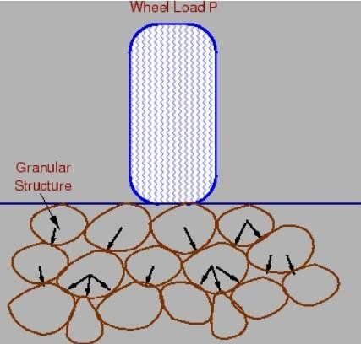
Figure 11: Load transfer in granular structure (Source: https://civil.iitb.ac.in/tvm/)
The wheel load acting on the pavement will be distributed to a wider area, and the stress decreases with the depth. Taking advantage of this stress distribution characteristic, flexible pavements normally have many layers. Hence, the design of flexible pavement uses the concept of layered system. Based on this, flexible pavement may be constructed in a number of layers and the top layer has to be of best quality to sustain maximum compressive stress, in addition to wear and tear. The lower layers will experience lesser magnitude of stress and low-quality material can be used. Flexible pavements are constructed using bituminous materials. These can be either in the form of surface treatments (such as bituminous surface treatments generally found on low volume roads) or, asphalt concrete surface courses (generally used on high volume roads such as national highways). Flexible pavement layers reflect the deformation of the lower layers on to the surface layer (e.g., if there is any undulation in sub-grade then it will be transferred to the surface layer). In the case of flexible pavement, the design is based on overall performance of flexible pavement, and the stresses produced should be kept well below the allowable stresses of each pavement layer.

Types of Flexible Pavements
The following types of construction have been used in flexible pavement:
- Conventional layered flexible pavement,
- Full - depth asphalt pavement, and
- Contained rock asphalt mat (CRAM).
Conventional flexible pavements are layered systems with high quality expensive materials are placed in the top where stresses are high-, and low-quality cheap materials are placed in lower layers.
Full - depth asphalt pavements are constructed by placing bituminous layers directly on the soil sub-grade. This is more suitable when there are high traffic and local materials are not available.
Contained rock asphalt mats are constructed by placing dense/open graded aggregate layers in between two asphalt layers. Modified dense graded asphalt concrete is placed above the sub-grade will significantly reduce the vertical compressive strain on soil sub-grade and protect from surface water.

Typical layers of a flexible pavement

Typical layers of a conventional flexible pavement include seal coat, surface course, tack coat, binder course, prime coat, base course, sub-base course, compacted sub-grade, and natural sub-grade.
- Seal Coat: Seal coat is a thin surface treatment used to water-proof the surface and to provide skid resistance.
- Tack Coat: Tack coat is a very light application of asphalt, usually asphalt emulsion diluted with water. It provides proper bonding between two layers of binder course and must be thin, uniformly cover the entire surface, and set very fast.
- Prime Coat: Prime coat is an application of low viscous cutback bitumen to an absorbent surface like granular bases on which binder layer is placed. It provides bonding between two layers. Unlike tack coat, prime coat penetrates into the layer below, plugs the voids, and forms a water tight surface.

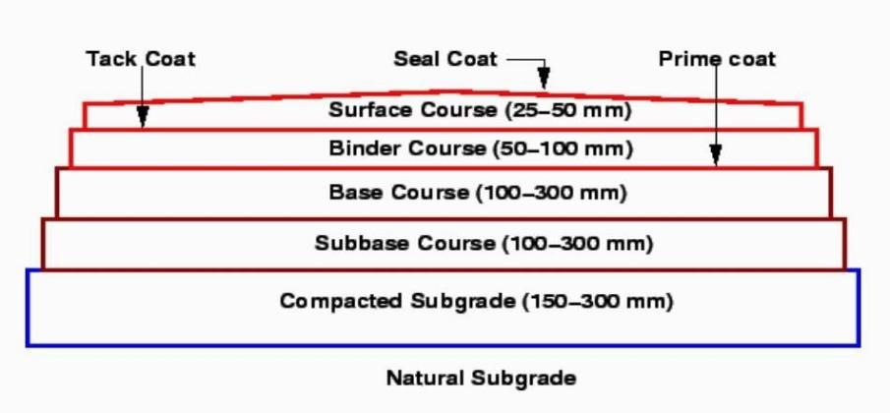
Figure 12: Typical cross section of a flexible pavement
(Source: https://civil.iitb.ac.in/tvm/)

- Surface course: Surface course is the layer directly in contact with traffic loads and generally contains superior quality materials. They are usually constructed with dense graded asphalt concrete (AC). The functions and requirements of this layer are:
  - It provides characteristics such as friction, smoothness, drainage, etc. Also, it will prevent the entrance of excessive quantities of surface water into the underlying base, sub-base and sub-grade,
  - It must be tough to resist the distortion under traffic and provide a smooth and skid- resistant riding surface,
  - It must be water proof to protect the entire base and sub-grade from the weakening effect of water.

- Binder course: This layer provides the bulk of the asphalt concrete structure. Its chief purpose is to distribute load to the base course. The binder course generally consists of aggregates having less asphalt and doesn't require quality as high as the surface course, so replacing a part of the surface course by the binder course results in more economical design.

- Base course: The base course is the layer of material immediately beneath the surface of binder course and it provides additional load distribution and contributes to the sub-surface drainage. It may be composed of crushed stone, crushed slag, and other untreated or stabilized materials.

- Sub-Base course: The sub-base course is the layer of material beneath the base course and the primary functions are to provide structural support, improve drainage, and reduce the intrusion of fines from the sub-grade in the pavement structure If the base course is open graded, then the sub-base course with more fines can serve as a filler between sub-grade and the base course A sub-base course is not always needed or used. For example, a pavement constructed over

a high quality, stiff sub-grade may not need the additional features offered by a sub-base course. In such situations, sub-base course may not be provided.
- Sub-grade: The top soil or sub-grade is a layer of natural soil prepared to receive the stresses from the layers above. It is essential that at no time soil sub- grade is overstressed. It should be compacted to the desirable density, near the optimum moisture content.

Failure of flexible pavements
The major flexible pavement failures are fatigue cracking, rutting, and thermal cracking. The fatigue cracking of flexible pavement is due to horizontal tensile strain at the bottom of the asphaltic concrete. The failure criterion relates allowable number of load repetitions to tensile strain and this relation can be determined in the laboratory fatigue test on asphaltic concrete specimens. Rutting occurs only on flexible pavements as indicated by permanent deformation or rut depth along wheel load path. Two design methods have been used to control rutting: one to limit the vertical compressive strain on the top of subgrade and other to limit rutting to a tolerable amount (12 mm normally). Thermal cracking includes both low- temperature cracking and thermal fatigue cracking.

Rigid Pavements
Rigid pavements have sufficient flexural strength to transmit the wheel load stresses to a wider area below. A typical cross section of the rigid pavement is shown in Figure 3. Compared to flexible pavement, rigid pavements are placed either directly on the prepared sub-grade or on a single layer of granular or stabilized material. Since there is only one layer of material between the concrete and the sub-grade, this layer can be called as base or sub-base course.

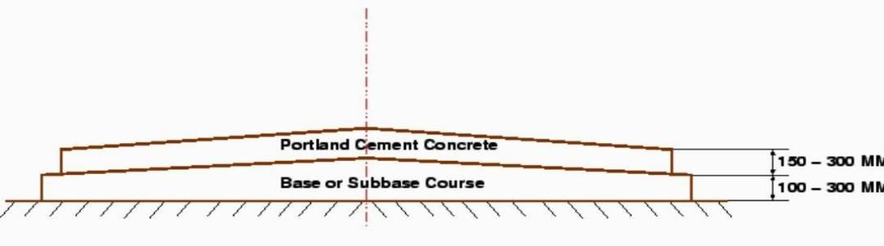
Figure 13: Typical cross section of rigid pavement
(Source: https://civil.iitb.ac.in/tvm/)

In rigid pavement, load is distributed by the slab action, and the pavement behaves like an elastic plate resting on a viscous medium. Rigid pavements are constructed by Portland cement concrete (PCC) and should be analyzed by plate theory instead of layer theory, assuming an elastic plate resting on viscous foundation. Plate theory is a simplified version of layer theory that assumes the concrete slab as a medium thick plate which is plane before loading and to remain plane after loading. Bending

of the slab due to wheel load and temperature variation and the resulting tensile and flexural stress.

Types of Rigid Pavements
Rigid pavements can be classified into four types:
- Jointed plain concrete pavement (JPCP),
- Jointed reinforced concrete pavement (JRCP),
- Continuous reinforced concrete pavement (CRCP), and
- Pre-stressed concrete pavement (PCP).

Jointed Plain Concrete Pavement: are plain cement concrete pavements constructed with closely spaced contraction joints. Dowel bars or aggregate interlocks are normally used for load transfer across joints. They normally have a joint spacing of 5 to 10m.

Jointed Reinforced Concrete Pavement: Although reinforcements do not improve the structural capacity significantly, they can drastically increase the joint spacing to 10 to 30m. Dowel bars are required for load transfer. Reinforcement helps to keep the slab together even after cracks.

Continuous Reinforced Concrete Pavement: Complete elimination of joints is achieved by reinforcement.

Failure criteria of rigid pavements
Traditionally fatigue cracking has been considered as the major, or only criterion for rigid pavement design. The allowable number of load repetitions to cause fatigue cracking depends on the stress ratio between flexural tensile stress and concrete modulus of rupture. Of late, pumping is identified as an important failure criterion. Pumping is the ejection of soil slurry through the joints and cracks of cement concrete pavement, caused during the downward movement of slab under the heavy wheel loads. Other major types of distress in rigid pavements include faulting, spalling, and deterioration.

Double Bituminous Surface Treatment (DBST)
Double bituminous surface treatment is a common type of pavement surfacing construction which involves two applications of asphalt binder material and mineral aggregate. The asphalt binder material is applied by a pressure distributor, followed immediately by an application of mineral aggregate, and finished by rolling. The process is repeated for the second application of asphalt binder material and mineral aggregate. The first application of aggregate is coarser than the aggregate used in the second application and usually determines the pavement thickness. The maximum size of mineral aggregate used in the second application is about one-half that of the first. When double bituminous surface treatments are properly designed and constructed, a relatively inexpensive pavement surface can be produced which will provide satisfactory performance for several years with

minimum maintenance costs. The double bituminous surface treatment's main function is to provide an all-weather, skid-resistant wearing surface that produces a water-resistant layer. In our project we have used an aggregate size of 19 mm for the first layer and 10mm for the second layer.

Single Bituminous Surface Treatment (SBST)
A single bituminous surface treatment (SBST), also known as a seal coat or chip seal, is a thin protective wearing surface that is applied to a pavement or base course. A SBST can provide: -
  - Waterproof layer to protect the underlying pavement.
  - Increased skid resistance.
  - A filler for existing cracks or raveled surfaces.
  - An anti-glare surface during wet weather and an increased reflective surface for night driving.
SBST are increasingly in use as a preventative maintenance procedure on flexible Pavements.

Highway drainage
The system which is designed for road for proper collection, removal and disposal of surface as well as sub-surface water is called as road drainage. To maintain the stability and durability of the road, the road surface and its foundation should be kept as dry as possible. This practice is only possible with proper and working road drainage system. Moreover, a good drainage of road helps to maintain the highway transportation with minimal cost. Pavement should be such that it should be at least 1.2 m above the GWT.

Types of Road Drainage:
- Surface Drainage
It is the road drainage in which the surface water of the road is collected and disposed within right-of-way of the road. Surface drainage is basically designed to prevent the flow of surface water to the shoulders, sub-grade or any other layer of the road surface.

Basic Functions of Surface Drainage:
  - To maintain the road surface completely dry from water.
  - To collect the drained off water from the road surface.
  - Increase the stability of the road or highway.
  - By using the gravitational force, carrying of collected water into nearby stream or river.

- Side Gutter
Side gutters are generally constructed parallel to the side of the road and it disposes the surface water efficiently. Below figure shows the side gutter or side drain in cutting and embankment provided for proper surface drainage. The section of side drain is generally trapezoidal, but generally triangular side gutters are also provided in cutting.

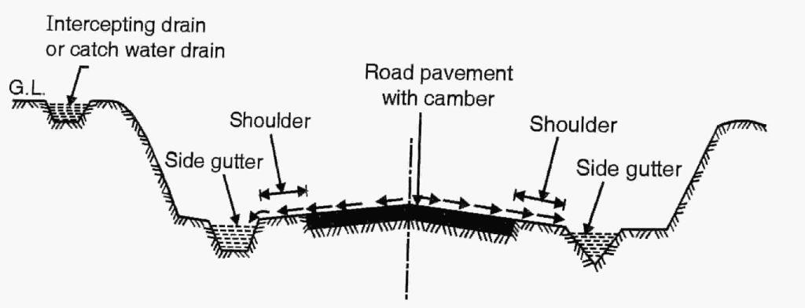
Figure 14: Side Gutter
(Source: https://civilengineeringnotes.com/road-drainage-system/)

Functions of Side Gutter:
  - The main function is to collect the surface water and further these side drains ultimately join the natural streams and rivers.
  - They can be constructed and maintained in very low budget. But they give unpleasant look due to deep ditch. Hence, they are not adopted when the traffic is heavy.

- Catch Water Drain
When the gutters or drains are additionally provided parallel to the road at higher level for collecting and disposing the surface water is known as catch water drain.
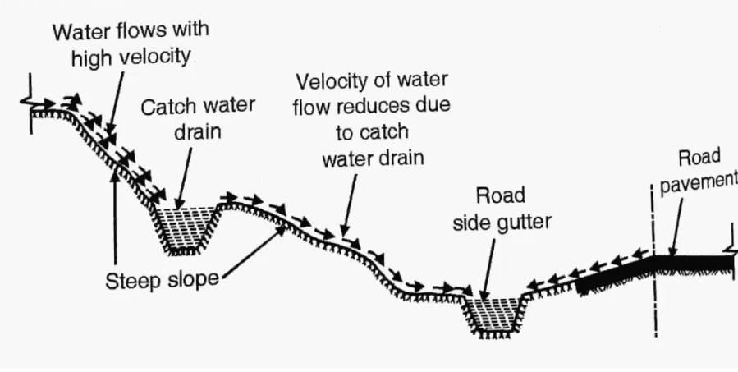
Figure 15: Catch Water Drain
(Source: https://civilengineeringnotes.com/road-drainage-
system/)

Functions of Catch Water Drain:
The catch water drain intercepts the large quantity of the surface water flow and also breaks the continuity of flow and thereby reduces the velocity of water and prevents the erosion and landslides and thereby protect the road pavement. Catch water also help in reducing the size of side gutters or side drains.

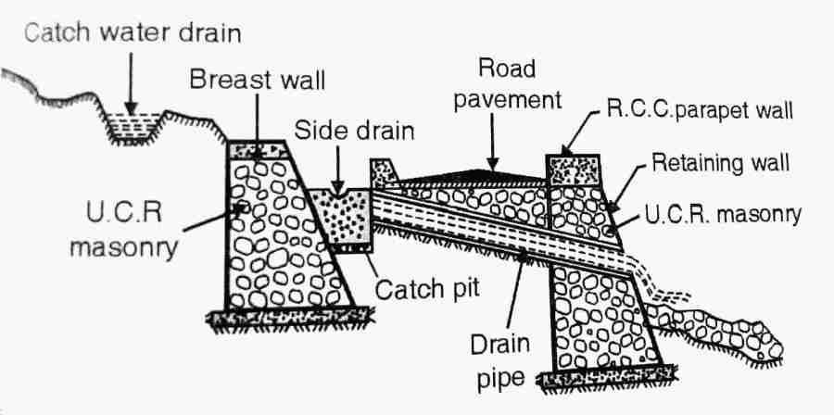
Figure 16: Catch Water Drain
(Source: https://civilengineeringnotes.com/road-drainage-system/)

Sectional area of catch water drains is generally 0.9 m × 0.9 m and should be constructed normally at 4.5 m from the road edge. If surface water flowing from the high-level ground towards the road is large then it is desirable to take this water across the road at regular intervals and then allow this water to flow through the pipe drain constructed through the road embankment to the natural stream.

- Sub-surface drainage of Road
Sub-surface drainage is the system in which the sub-soil water from underside of road pavement is collected and removed efficiently. It is generally adopted to control the moisture content of road sub-grade.

If the moisture content in the sub-soil increases, it can weaken the road structure. Hence it becomes more important to control the moisture of road sub-grade.

Factors increasing the sub-soil moisture content are as follows:
  - Increase in ground water table.
  - Water seepage from adjoining areas.
  - Surface water percolation through joints and cracks.
  - Rise of the moisture above ground water table which is caused by the capillary action.

Thus, longitudinal drains, cross drain and impervious bituminous layer are provided to prevent the rise in sub-soil moisture or sub-surface moisture and it’s specially provided to control the capillary rise.

Functions of sub-surface drainage:
  - It prevents and controls the moisture content of the road sub-grade.

  - To maintain the bearing capacity of the sub-grade soil by restricting the entry of water into it.
  - To reduce the capillary rise, because sometimes due to capillary action, the water rises into the sub-grade from the ground water.

2.18 Retaining Structure:
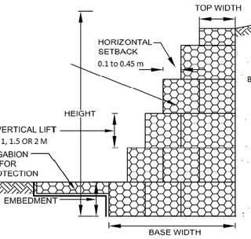
A retaining wall is a structure designed and constructed to resist the lateral pressure of soil, when there is a desired change in ground elevation that exceeds the angle of repose of the soil. Retaining walls are used for supporting soil laterally so that it can be retained at different levels on the two sides. Retaining walls are structures designed to restrain soil to a slope that it would not naturally keep to (typically a steep, near-vertical or vertical slope). They are used to bound soils between two different elevations often in areas of terrain possessing undesirable slopes or in areas where the landscape needs to be shaped severely and engineered for more specific purposes like hillside farming or roadway overpasses.
Figure 17: Gabion Retaining Wall
(Source: https://cadbull.com/detail)

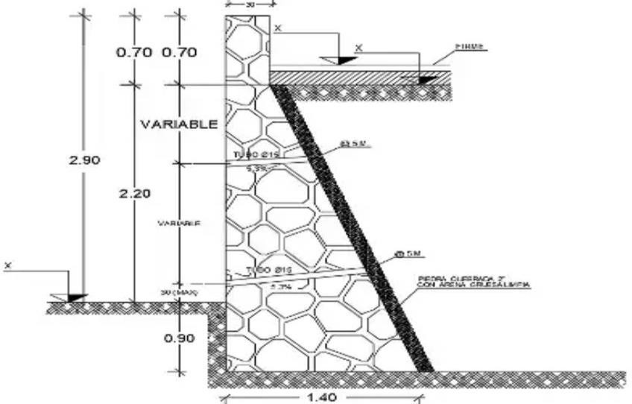
Figure 18: Masonry Retaining Wall
(Source: https://cadbull.com/detail)

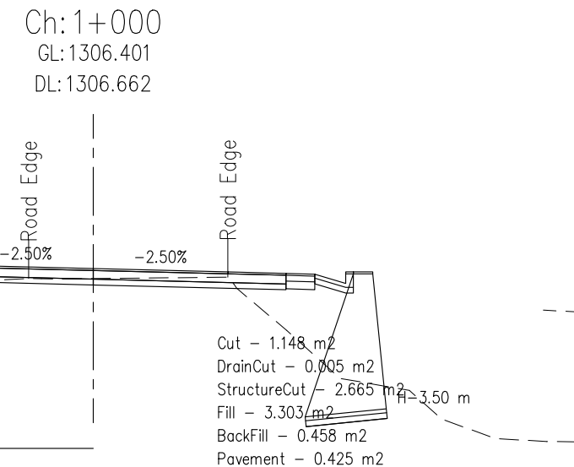

Figure 19: Masonry retaining structure of chainage 1+000m

METHODOLOGY

Map Study
The project began with a desk study of relevant Google Earth images to examine the alignment's current state. The alignment between ratopati and kalamashi bus park was marked in the Google Earth engine, and a preliminary evaluation of the project's viability in terms of accessibility and suitability was carried out. We concluded from the desk study that the alignment was longer than the desired length i.e. 6.9 km.

Reconnaissance
After the map study, the walkover survey or recce of ratopati– kalamashi alignment was done to confirm the information gathered from the google earth. During reconnaissance, existing condition of the alignment was analyzed. The soil samples were also analyzed and the existing retaining structures and drains in the alignment were studied. Number of instrument stations to establish and details accessibility were also reviewed for further planning and proper execution of the project.

Topographic Survey
The benchmark was established near the ratopati mandir with the help of GPS and topographic survey was carried out. For this, coordinates and reduced level were transferred from known points to unknown points using total station. Topographic survey was conducted for the entire 6.9 km road section marking all the existing features like buildings, trees, poles and walls along with the ground points and existing road parameters to a distance of 15m on either side being a feeder road category.

Office Works
Following works were carried out as office work:
  - Preparation of contour map throughout the alignment
  - Designs of alignment with plan, profile and cross-section
  - Quantity Estimation
  - Rate analysis and Cost Estimation
  - Preparation of detail project report

Software for Design
Manual designing and estimation these days are being replaced by the use of software, which reduces time and provides maximum efficiency. These design software’s requires data and must be inputted by the users. These days different software are used for designing and estimation of any project along with planning and scheduling works. For the project

work software like MS Excel, MS Word, AutoCAD, SW-DTM, and SW Road have been used as per the necessity of work.

SW-DTM
SW DTM has been used to project the obtained coordinates from site to the AutoCAD using the import from excel feature. The projection of coordinates was made in the form of ENZ format. SW-DTM was also used to draw boundaries to the alignment.

AutoCAD
AutoCAD was used to project the everyday obtained field coordinates to verify the alignments track. Complete data were plotted in AutoCAD and then a DTM file was created which was then loaded in the SW ROAD. Besides this it was also used to clip contours and analyze the output from SW road as it has a user-friendly and easy interface.

SW Road
SW Road was used for majority of the project work. The software was given an input to load the file from AutoCAD and then alignment Ratopati Ganesh Mandir – Kalamashi Bus park was drawn in the SW road using the Alignment tool. Similarly horizontal curves were given with inputs like super elevations and extra widenings and also profiles and cross sections were drawn with Drain type G and F, masonry dynamic retaining wall. All the necessary drawings were obtained from SW road. Also, estimation was done after giving inputs of rate from the district rate of Bhaktapur 2078/2079 and quantity and costs were obtained in the excel format.

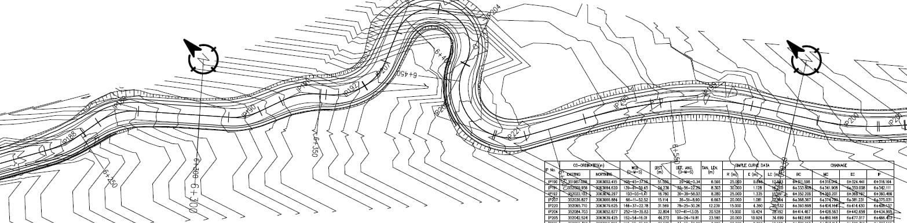

Figure 20: Plan of the Alignment from Chainage 6+300 to 6+600

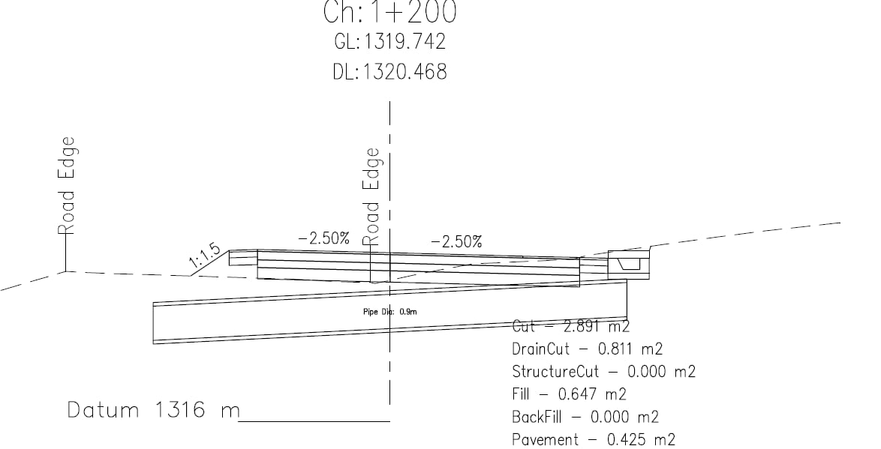
Figure 21 : Cross Section of Road at Chainage 1+200 m
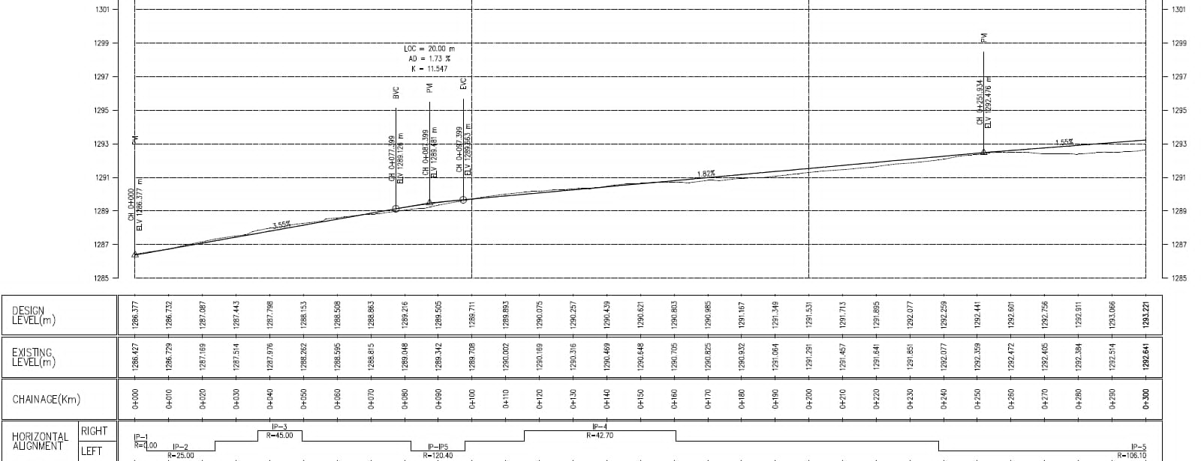

Figure 22 : Profile of the Road alignment from chanage 0+000 to 0+300 m

DETAIL ENGINEERING DESIGN

Adopted Design Standard and Parameters

S.N. | Design Parameters | Measurement | Remarks
1 | Road Type | Feeder road, Class IV | Road connects Ratopati to kalamashi bus park leading to NagarKot.
2 | Terrain Type | Rolling | Percent cross slope = (10-25)
3 | Design Speed | 30 km/h | Mountainous road, Class IV
4 | Carriageway width | 7 m | Double lane
5 | Shoulder width | 0.75 m on each side
6 | Formation width | 8.5 m
7 | Maximum gradient | 15.33% | Excessive excavation; Settlement impact
8 | Radius of Horizontal  Curve | Not less than 20 m
9 | Radius of Hairpin  Bend | < =15m
10 | Right of Way | 30m
11 | Soil Type | Disintegrated Rock | Field observation
12 | Stopping Distance | 30 m

Table 14: Adopted Design Standard and Parameters

Horizontal Alignment

Horizontal Curvature
When the centerline of road deviates from its original direction, horizontal curve needs to be introduced to provide smooth and safe movements of vehicles.

Minimum Radius of Horizontal Curve
The minimum radius is adopted as 20 m as per design standard.
Sample Calculation for Horizontal Curve for chainage 2 + 800.049 m


Here,
Radius of Curve (R) = 35 m Deflection angle (Δ) = 31 Chainage of IP = 2800.049 m Now,
Tangent Length (T) = R tan (Δ/2) = 35 × tan (Δ/2) = 9.706 m Length of Curve (L) = πRΔ/180 = 18.937 m
So,
`Beginning of Curve (BC) = Chainage of IP – Tangent Length
= 2800.049 – 9.706
= 2790.294 m
Mid of Curve (MC) = BC + L/2 = 2799.763 m End of Curve (EC) = BC + L = 2809.231 m

Extra Widening
Extra widening on the curves of the road refers to the additional width of the carriageway that is required on a curved section of the road over and above the width required on the straight section. Additional width at the horizontal curve is required due to the following reasons.
  - Rigidity of wheelbase: Due to the rigidity of wheelbase, the rear wheel of the vehicle moving along the curve does not follow the same track/path taken by front steering curves i.e. Off-tracking.
  - Preferential use of outer lanes: A driver prefers the outer lane for greater visibility and easy gradient.
  - More clearance between opposite vehicles: Where the road visibility is inadequate, drivers, to be on the safer side, have a tendency to keep greater clearance between opposite vehicles on curves of the road.
  - Difference in slip angle: It has been observed that when the vehicle is understeering, the slip angle of the front tires is more than of the rear tire/wheels and the front tire may tend to go out of pavement. In oversteering vehicles vice versa.

Sample Calculation
For Chainage 0 + 2800.049 m Radius of Curve = 35 m Design Speed = 30 km/hr.
So,
Extra Widening = Mechanical Widening + Psychological Widening
= n l^2 + v

2R 9.5 R^0.5

= 1 ×6.1^2 + 30

2 ×35
= 1.065 m

9.5 ×35^0.5

Vertical Alignment
Vertical curves are used to provide a smooth transition between roadway grades. A vertical curve is composed of a parabolic curve that provides a constant rate of change of grade. A parabolic curve “flattens” the vertical alignment at the top or bottom of a hill to increase the driver's sight distance. The criteria to be adopted are that minimum sight distance shall be equal to stopping sight distance laid down.

Super Elevation
For Chainage 2+800.049 m Radius of Curve = 35 m Design Speed = 30 km/hr.
Neglecting friction coefficient for 75 % design speed e = V²/225R
= 30² / (225×35)
= 0.114 > 0.07
Now,
f = v² / (g R) – 0.07
= 8.3333²/ (9.81 × 35) – 0.07
= 0.132 < 0.15
The design speed of 30 km/hr. is okay for the radius 35 m.

Drainage System

Road Side Drain
A roadside drain, also known as a roadside ditch or a gutter, is a channel constructed along the side of a road to collect and carry away rainwater and other runoff. The purpose of a roadside drain is to prevent water from accumulating on the road, which can cause safety hazards for drivers and pedestrians, as well as damage to the road surface and adjacent properties. Roadside drains are typically constructed with a sloping bottom and are designed to carry water away from the road and into a nearby natural watercourse, such as a stream or river. They may also be connected to a storm water management system, which collects and treats the runoff before discharging it into the environment.
In our case, we used drain type G and F as provided by the SW Road software.
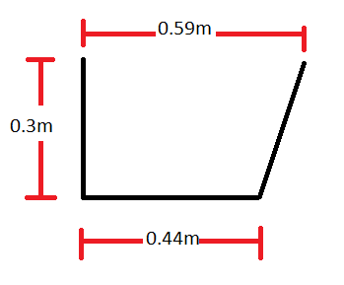
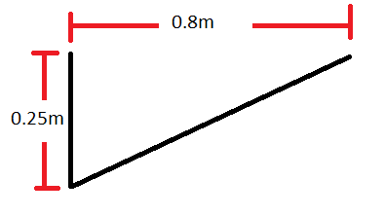

.

Fig 23: Dimension of Drain type-F Fig 24: Dimension of Drain type-G

For Drain-F
Tw | 1
Depth (D) | 0.3
Area(A) | 0.15
Perimeter(P) | 1.344031
Hydraulic Radius(R) | 0.111605

For Drain-G
B | 0.44
D | 0.3
Tw | 0.59
Area(A) | 0.1545
Wetted Perimeter(P) | 1.66541
R | 0.09277

Table 15: For Drain-F Table 16: for Drain-G

Cross Drains
For cross drainage structure, 11 pipe culverts of diameter 90 cm and one RCC causeway was provided to drain out the water in cost optimized way from the drains for safe and efficient disposal.

Sample Calculation:
Chainage: 6450 km
Diameter of pipe (D) = 0.9 m Area (A) = 0.079847142 m²
Hydraulic Radius (R) = 0.100302492 m
Maning’s Roughness number (n) = 0.013 (concrete)
Laying Slope (So) = 1 in 20 (5%)
From Manning's equation, Q = (A × R^{2/3} × S^{1/2})/n
Q = 0.296489 m³/s
The pipe of 0.9 m can carry 0.296489 m³/s of discharge at any time.

Retaining Structures
Retaining structures are used in road construction to support the soil and prevent erosion or collapse of the roadbed. They are typically built in areas where the road is constructed on a slope, or where there is a significant height difference between the road and adjacent land or water bodies.

There are several types of retaining structures that may be used in road construction, including:
  - Gabion Walls: Gabions are wire mesh baskets filled with rocks or other materials, which are placed in layers to form a wall. They are often used in areas where the soil is unstable, as they allow water to flow through the wall and prevent pressure buildup.
  - Concrete Retaining Walls: These are often used in areas where the slope is too steep for gabion walls to be effective. Concrete retaining walls can be precast or cast-in- place, and are often reinforced with steel bars for added strength.
  - Mechanically Stabilized Earth (MSE) Walls: MSE walls are made up of alternating layers of compacted soil and geotextile fabric, with a facing made of concrete or other material. They are designed to resist lateral pressure from the soil and can be used in areas with slopes of up to 70 degrees.
  - Sheet Piling: Sheet piling involves driving interlocking steel sheets into the ground to form a barrier. They are often used in areas where the soil is soft or unstable, and where other types of retaining walls may not be effective.

The retaining structures provided in our project were gabion retaining wall, masonry retaining wall, gabion breast wall and masonry breast wall.

PAVEMENT DESIGN

Method of Flexible Pavement Design
There are various methods for design of flexible pavement like Bermister Theory, CBR Method, Boussinesq’s Theory, AASTHO Method, Road Note 31, IRC:37, IRC SP:72etc.

IRC SP:72

SP:72, published in 2007 by the Indian Roads Congress, represents a specialized and economical pavement design framework tailored for rural road infrastructure. To ensure structural adequacy while maintaining economy, the Indian Roads Congress (IRC) developed SP:72 – “Guidelines for the Design of Flexible Pavements for Low Volume Rural Roads.”
This guideline provides a simplified CBR-based pavement design approach for roads carrying cumulative traffic less than 2 million standard axles (msa). SP:72 was first published in 2007 and later revised in 2015.
SP:72provides detailed guidance on:
    - Pavement materials selection and properties
    - Pavement thickness design methods
    - Construction techniques and quality control
    - Pavement performance monitoring and maintenance

For traffic data collection and analysis, subgrade characterization and soil testing, guidelines such as Road Note 31 and IRC:37 can be used and aligned with the construction of flexible road.

SP:72 adopts an empirical CBR-based design approach. Thus, the structural thickness of the pavement is determined primarily by:
- Subgrade strength (soaked CBR value)
- Cumulative traffic loading (msa)
The basic principle is:
- Lower CBR → thicker pavement
- Higher traffic → thicker pavement

Overall, SP:72 is a valuable resource for pavement engineers and designers, providing practical guidance on all aspects of flexible pavement design and construction on low volume roads.

Design catalogue
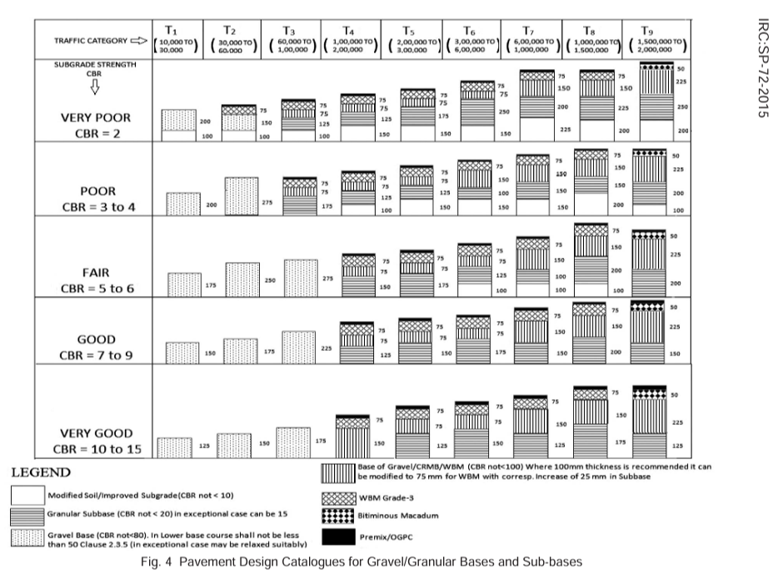

Traffic Category | Cumulative ESAL Applications
T₁ | 10,000–30,000
T₂ | > 30,000–60,000
T₃ | > 60,000–100,000
T₄ | > 100,000–200,000
T₅ | > 200,000–300,000
T₆ | > 300,000–600,000
T₇ | > 600,000–1,000,000
T₈ | > 1,000,000–1,500,000
T₉ | > 1,500,000–2,000,000
Figure 25: Pavement Design Catalogues for Gravel/Granular Bases and Sub-bases

Table 17: Traffic category from cumulative ESAL application

The basis of design chart is that with the CBR value and traffic, various categories are divided and the pavement thickness for each category can be easily known from the design chart.

Model | Curb weight (pounds) | Curb weight (metric ton)
2020 Toyota Supra 2 Door Coupe | 3397 | 1.54
2020 Kia Telluride SX 4 Door AWD | 4482 | 2.03
2020 Subaru Outback Ltd 4 Door AWD | 3730 | 1.70
2020 Chevy Silverado LT Trail Boss 4 Door  Crew Cab | 5105 | 2.32
2020 Honda Pilot Elite 4 Door AWD | 4319 | 1.95
2020 Kia Soul GT-Line 4 Door Wagon | 2844 | 1.29
2020 Ford Escape SE 4 Door | 3299 | 1.50
2020 Lexus LS 500 4 Door Sedan | 4707 | 2.14
2020 Toyota Supra 3.0 2 Door Coupe | 3397 | 1.54
2020 Buick Regal TourX 4 Door Wagon AWD | 3708 | 1.68
Average |  | 1.77

Table 18: Determination of average weight of test vehicles
(Source: https://family.lovetoknow.com/vehicles/list-of-car-weights)
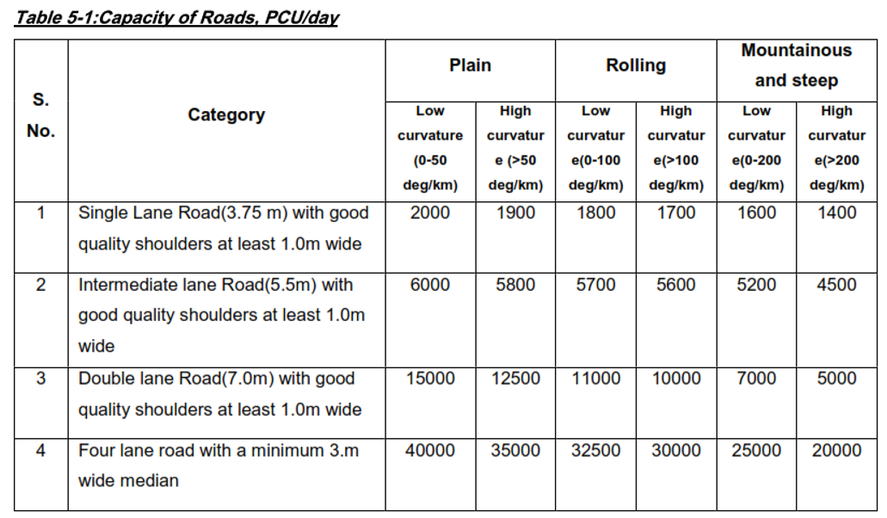

Table 19: Capacity of Roads, PCU/Day

(Source: NRS-2070)

Determination of future traffic
Table: Determination of traffic volume
DAY 1 MORNING
Direction | Trip no |  | Journey Time |  |  |  | Stopped Delay |  |  | No of vehicle from opposite direction |  |  |  | Vehicles in same direction
 |  |  |  |  |  |  |  |  |  |  |  |  |  | overtaking |  |  | overtaken
 |  |  | Min |  | Sec |  | Min | Sec |  | Bike (0.5) | Car (1) | Mini truck (1.5) | Bus (3) | Bike | Car | Bus | Bike | Car
R-K | 1 |  | 14 |  | 25 |  | 0 | 0 |  | 45 | 5 | 4 | 3 | 5 | 4 | 1 | 0 | 0
 | 2 |  | 14 |  | 16 |  | 0 | 0 |  | 43 | 6 | 2 | 2 | 4 | 1 | 1 | 1 | 0
 |  |  | 14.34166667 |  |  |  | 0 | 0 |  | 39.5 |  |  |  | 7.75 |  |  | 0.25
K-R | 1 |  | 13 |  | 46 |  | 0 | 0 |  | 38 | 5 | 8 | 5 | 10 | 0 | 3 | 0 | 0
 | 2 |  | 12 |  | 51 |  | 0 | 0 |  | 30 | 3 | 4 | 5 | 6 | 6 | 4 | 1 | 0
 |  |  | 13.80833333 |  |  |  | 0 | 0 |  | 45 |  |  |  | 17.5 |  |  | 0.25
 |  | q1= |  | 1.865 |  | pcu/min
 |  | q1'= |  | 2.016 |  | pcu/min

DAY 1 EVENING

q2= | 2.2931 | pcu/min
q2'= | 1.627 | pcu/min

DAY 2 MORNING
q3= | 1.8605 | pcu/min
q3'= | 2.0386 | pcu/min

DAY 2 EVENING
DIrection | Trip no | Journey Time |  | Stopped Delay |  | No of vehicle from opposite direction |  |  |  | Vehicles in same direction
 |  |  |  |  |  |  |  |  |  | overtaking |  |  | overtaken
 |  | Min | Sec | Min | Sec | Bike(0.5) | Car(1) | Mini truck(1.5) | Bus(3) | Bike | Car | Bus | Bike | Car
R-K | 1 | 15 | 34 | 0 | 0 | 55 | 10 | 6 | 2 | 2 | 2 | 1 | 3 | 0
 | 2 | 14 | 29 | 0 | 0 | 42 | 9 | 6 | 7 | 0 | 0 | 0 | 0 | 0
 |  | 15.025 |  | 0 | 0 | 56.25 |  |  |  | 3 |  |  | 0.75
K-R | 1 | 14 | 58 | 0 | 0 | 57 | 10 | 5 | 5 | 2 | 0 | 0 | 1 | 0
 | 2 | 14 | 10 | 0 | 0 | 51 | 6 | 5 | 3 | 1 | 0 | 0 | 1 | 0
 |  | 14.56666667 |  | 0 | 0 | 54.5 |  |  |  | 0.75 |  |  | 0.5

q4= | 1.9178 | pcu/min
q4'= | 1.9093 | pcu/min

DAY 3 SATURDAY
Direction | Trip no | Journey Time |  | Stopped Delay |  | No of vehicle from opposite direction |  |  |  | Vehicles in same direction
 |  |  |  |  |  |  |  |  |  | overtaking |  |  | overtaken
 |  | Min | Sec | Min | Sec | Bike(0.5) | Car(1) | Mini truck(1.5) | Bus(3) | Bike | Car | Bus | Bike | Car
R-K | 1 | 14 | 22 | 0 | 0 | 69 | 20 | 8 | 2 | 5 | 1 | 0 | 0 | 0
 | 2 | 14 | 23 | 0 | 0 | 59 | 18 | 5 | 2 | 3 | 0 | 0 | 1 | 0
 |  | 14.375 |  | 0 | 0 | 66.75 |  |  |  | 2.5 |  |  | 0.25
K-R | 1 | 14 | 44 | 0 | 0 | 77 | 16 | 7 | 1 | 2 | 0 | 1 | 1 | 0
 | 2 | 14 | 32 | 0 | 0 | 74 | 12 | 8 | 1 | 4 | 3 | 0 | 1 | 1
 |  | 14.63333333 |  | 0 | 0 | 66 |  |  |  | 4.5 |  |  | 2

q5= | 2.3528 | pcu/min
q5'= | 2.3872 | pcu/min

Volume (pcu/min)
DAY1(THURSDAY) | Morning | 1.865 | 2.016
 | Evening | 2.2931 | 1.627
DAY2(FRIDAY) | Morning | 1.8605 | 2.0386
 | Evening | 1.9178 | 1.9093
DAY3(SATURDAY) | Noon | 2.3528 | 2.3872
 | Volume (q)=2.3872pcu/min

FOR ASSUMMING PURPOSE,
For 15 yrs. perspective period,
Present Day Traffic (P) =(2.3872*60*24)PCU/day
= 3437.568 PCU /day
Growth rate (r) = 5 % per year
1PCU= 2T
Construction period (x) = 2 years
Design period (n) = 15 years
LDF=1 (Intermediate Lane)
Calculations:
Present Day Traffic (P) = 3437.568 PCU/day
Anticipated Traffic volume after 2 years (A) = P × (1+r) ^ x
= 3437.568 × (1.05) ^ 2
= 3789.918 PCU/day
Equivalent Factor (EF)= (2 T / 8 T) ⁴ = 0.0039
Cumulative Number of Axle at the end of Design Period (Ns)
Ns = 365 × A ×{((1+r) ^n) -1}/r) × LDF × EF
= 365 × 3789.918 × {(1+0.05) ^ 15 – 1)/0.05} × 1 × 0.0039
= 116601.818 standard axle
= 0.1 msa

It was seen during the time of traffic volume survey by floating car method, there was sparse or no presence of vehicle having high impact or damage on the pavement such as heavy trucks.This leads us to conclude that this road is a rural type road with potential urbanization .Therefore,we can take Cumulative Number of Axle at the end of Design Period (Ns) to be 2msa as per IRC:37 and adopt SP-72 for the design of pavement.

LABORATORY TEST

California Bearing Ratio (CBR)
In order to determine the subgrade strength, the CBR test was performed. For this, seven different soil samples were collected from the field. Each sample were sieved through 20 mm sieve and was compacted in three layers by 56 blows and then was subjected to a CBR testing machine where load was applied at the rate of 1.25 mm/min. Load vs penetration curve was plotted and the load for 2.5 mm and 5 mm penetration was found out after correction if needed.
CBR value was obtained using following formulae.

CBR2.5 = load or pressure for 2.5 mm penetration of soil sample load or pressure for 2.5 mm penetration of standard soil

CBR5 = load or pressure for 5 mm penetration of soil sample load or pressure for 5 mm penetration of standard soil

Normally, CBR value goes on decreasing with the increase in penetration, so CBR at 2.5 mm is expected to be more than that at 5 mm. The higher value is adopted as a CBR value.
Penetration (mm) | Standard load (kg)
2.5 | 1370
5 | 2055
7.5 | 2630
10 | 3180
12.5 | 3600
Table 20: Standard Load for Various Penetration Values
(Source: California Division of Highways)

Deflection in division | Load applied (kN)
93.5 | 0.3
187.1 | 0.6
280.3 | 0.9
374.6 | 1.2
467.8 | 1.5
561.1 | 1.8
654.6 | 2.1
748.1 | 2.4
842.6 | 2.7
935.4 | 2
Table 21: California Chart for Determination of Load
(Source: California Division of Highways)

Determination of CBR value

From the CBR test of 7 samples, following result was obtained.
Chainage | CBR%
1+170 | 10.263
2+480 | 2.625
3+100 | 11.399
3+960 | 1.622
4+790 | 2.227
5+580 | 9.452
6+820 | 9.722

Table 22: CBR values from testing of sample

CBR Value below 5% | CBR value above 5% | % of exceedance | Rank
2.625 | 11.399 | 25 | 1
2.227 | 10.263 | 50 | 2
1.622 | 9.722 | 75 | 3
 | 9.452 | 100 | 4

Table 23: Classifying CBR above and below 5%

Figure 26: CBR vs % of exceedance graph for CBR values >5%

From graph (At 87.5% exceedance),
CBR (>5%) = 9.58% And, CBR (<5%) =1.622%

For CBR value greater than 5%, assuming it as 9%. And for CBR less than 5%, assuming it as 5% with capping layer of 300mm.
As per the traffic forecasting, it is observed that the traffic is of low volume.
Thus, according to irc:37, minimum ESAL=2 msa
From the design catalogue, the thickness of pavement layers are: -
For CBR= 9% For CBR= 5%
Sub-base = 150 mm Capping layer = 300mm
Base = 225 mm Sub-base = 200 mm
Surface course = 50 mm Base = 225 mm
Surface course = 50 mm

Pavement materials,
Capping layer - Gravel or suitable soil of equivalent CBR of 5%
Sub-base - Granular (CBR not< 20, in exceptional case 15)
Base - Gravel WBM/CRMB
Surface course - Bituminous Macadam
Wearing course - Premix/OGPC

The distribution of CBR are done according to the below segments within certain chainage.
Segment | Chainage | CBR | Remark
S1 | 0+000-1+170 | 9%
S2 | 1+170-3+100 | 5% | Capping layer
S3 | 3+100-3+960 | 9%
S4 | 3+960-4+790 | 5% | Capping layer
S5 | 4+790-6+989.036 | 9%

Table 24: Distribution of CBR according to test done considering homogeneity in sections

PROJECT COST ESTIMATE
The cost estimate of the project has been done by using the district rate of Bhaktapur 2078/2079.

Quantity Estimate
Quantity estimation is an essential part of highway construction. It helps to determine the amount of material required for the construction project, and it helps to ensure that the project stays within budget. Various quantities like earthwork, drains, retaining walls and other essential entities are estimated for the project. The detail quantity estimation has been attached to ANNEX IV.
Abstract of Quantity
Description | Quantity | Unit
Drain | 6900.369 | M³
Pavement | 2742.178 | M³
Base | 12339.8 | M³
Subbase | 9292.23 | M³
ShoulderLayer-1 | 518.4459 | M³
ShoulderLayer-2 | 1555.338 | M³
ShoulderLayer-3 | 2073.784 | M³
Shoulder | 21774.73 | L
Cut | 67322.49 | M³
Fill | 17819.45 | M³
Drain Cut | 5510.677 | M³
Structure Cut | 7959.99 | M³
Backfill | 1374.388 | M³
Masonry Retaining Wall | 13175.02 | M³
Capping | 6436.167 | M³
Causeway | 1 | Num
Pipe Culvert | 11 | Num
Lane Marking | 1397.807 | M²
Regulatory Sign | 20 | Num
Zebra Crossing | 117 | M²

Table 25: Abstract of Quantity

Rate Analysis
Rate analysis of a highway project involves determining the unit rates for various items of work such as excavation, earthwork, concrete work, and asphalt work, etc. The process involves identifying the quantities of various items of work, determining the cost of materials, labor, and equipment required for each item of work, and then calculating the unit rate. The unit rate is the cost per unit of measurement for a particular item of work, such a cost per cubic meter of excavation or cost per square meter of asphalt pavement. The unit rate can be used to estimate the cost of a project by multiplying the unit rate by the quantity of work required.
The rate analysis of a highway project can be performed using various methods, such as
manual calculation, spreadsheet software, or specialized software tools. The accuracy of the rate analysis depends on the accuracy of the input data, such as the quantities of work, the cost of materials, and the productivity of labor and equipment.
Factors that can affect the unit rates of various items of work include the type and quality of materials used, the complexity of the work, the availability of labor and equipment, and the location of the project. Therefore, it is important to conduct a detailed site investigation and to obtain accurate data for the rate analysis.
The detailed rate analysis was done using the DoR norms and District Rate of Bhaktapur 2081/82 and has been attached to ANNEX IV.

SN | Norms No. | Description of Work | Unit | Item Unit Rate
1 |  | PIPE DRAIN, PIPE CULVERTS & CONCRETE CHANNELS
1.01 | 07.02(D) | Laying RCC 900mm internal dia. Pipe | m | 8,099.82
2 |  | EARTH WORK
2.01 | 09.04(I-B-i) | Ordinary Soil Depth upto 3m By Mechanical Means | cum | 98.12
2.02 | 09.01(I-B) | Roadway Excavation in all types of soil by mechanical means. | cum | 65.42
2.03 | 09.09(B) | Construction of Embankment with Material Deposited from Roadway Cutting(With Machine) | cum | 329.03
2.04 | 09.04(I-A-i) | Ordinary Soil Depth upto 3m By Manual Means | cum | 1,003.38
3 |  | SUB GRADE
3.01 | 10.08 | Laying of hand pack Stone soling | cum | 8,239.64
3.02 | 10.01(A) | Scarifying Existing Road Surface to a Depth of 50 mm by Manual Means | sqm | 39.04
3.03 | 10.04(II) | Compacting original ground supporting embankment | cum | 72.45
3.04 | 10.03 | Construction of Subgrade and Earthen Shoulders with approved Material (capping layer) | cum | 4,142.99
4 |  | SUB BASE, BASE, HARD SHOULDER & GRAVEL WEARING
4.01 | 12.06(B) | Water Bound Macadam by Mechanical Means | cum | 5,715.62
4.02 | 12.01(A) | Providing and laying Granular Sub-Base Material By Mechanical means | cum | 4,393.03
5 |  | BITUMINOUS SURFACE AND BASE COURSE
5.01 | 13.03 | Bituminous Macadam | cum | 17,725.09
5.02 | 13.06 | Bituminous Concrete / Asphalt Concrete | cum | 25,965.67
5.03 | 13.01(B) | Prime Coat, with MC 30 / 70 by Manual Means | lit | 302.12
5.04 | 13.02(B) | Tack coat with Bitumen on prepared surfaces By Manual Means | lit | 228.49
6 |  | TRAFFIC SIGN, ROAD MARKING & OTHER ROAD APPURTENANCES
6.01 | 15.09(i) | Road Marking with Hot Applied Thermoplastic Compound with Reflectorizing Glass Beads on Bituminous Surface on smooth surface | Sqm | 1,034.92
6.02 | 15.01 | Non-Reflective Traffic Signs | nos | 5,183.17
6.03 | 15.05 | Painting two coats on Steel surfaces | Sqm | 222.89
7 |  | CONCRETE FOR STRUCTURES
7.01 | 20.01 | PCC M10(1:3:6) | cum | 11,398.39
7.02 | 20.02(B) | PCC Grade M20 | cum | 14,419.84
7.03 | 20.05 | Providing and laying, fitting and placing HYSD bar reinforcement in sub-structure | t | 142,907.48
7.04 | 20.02(C) | RCC Grade M20 | cum | 14,399.67
7.05 | 20.09 | Providing and laying, fitting and placing HYSD bar reinforcement in super-structure | t | 146,133.23
8 |  | RIVER TRAINING & PROTECTION WORKS
8.01 | 24.01(A-ii) | Gabion Box size 2 X 1 X 1 m (11 sqm) | cum | 7,383.45
8.02 | 24.01(B-ii) | Gabion Box size 2 X 1 X 1 m (11 sqm) | cum | 7,845.97
8.03 | 24.16 | Providing and laying Filter material underneath pitching in slopes | cum | 8,598.44
9 |  | MASONRY FOR STRUCTURES
9.01 | 26.05(A) | Random Rubble Masonry in Cement mortar (1:4) | cum | 14,300.25
9.02 | 26.06(A) | Random Rubble Masonry in Cement mortar (1:6) | cum | 13,789.51

Table 26: Summary of Rate Analysis

Abstract of Estimated Cost
The Abstract of Cost gives the information about the cost of various items that has been used in the project. Per kilometer cost of our project was found out to be Rs. 66793739.68 with 4 % contingencies and 13 % VAT.
Item No. | Description | Amount | %
1 | PIPE DRAIN, PIPE CULVERTS & CONCRETE CHANNELS | 890,979.76 | 0.17
2 | EARTH WORK | 11,823,526.90 | 2.30
3 | SUB GRADE | 52,273,067.07 | 10.15
4 | SUB BASE, BASE, HARD SHOULDER & GRAVEL WEARING | 129,350,875.42 | 25.11
5 | BITUMINOUS SURFACE AND BASE COURSE | 68,108,973.11 | 13.22
6 | TRAFFIC SIGN, ROAD MARKING & OTHER ROAD APPURTENANCES | 1,671,364.62 | 0.32
7 | CONCRETE FOR STRUCTURES | 51,976,456.10 | 10.09
8 | RIVER TRAINING & PROTECTION WORKS | 1,426,161.82 | 0.28
9 | MASONRY FOR STRUCTURES | 197,590,337.04 | 38.36
A | Total Estimated Cost | 515,111,741.83 | 100.00
B | Work Charge Establishment Cost @ 2% of (A) | 10,302,234.84
Item No. | Description | Amount | %
C | Miscellaneous Minor Cost @ 2% of (A) | 10,302,234.84
D | VAT @ 13% (A) | 66,964,526.44
E | Total Estimated Cost with Contingencies (4%) and VAT (A+B+C+D) | 602,680,737.94
F | Physical Contingencies @ 10% of (A) | 51,511,174.18
G | Price Contingencies @ 10% of (A) | 51,511,174.18
H | Grand Total Estimated Cost with Contingencies and VAT (E+F+G) | 705,703,086.31
I | Total Length of Road (km) | 6.99
J | Cost per km with Contingencies (4%) and VAT (Excluding Physical and Price Contingencies) (E/I) | 86,232,756.90

Table 27: Abstract of Estimated Cost

Figure 26: Pie Chart of Abstract of Cost

RESULT
The detail design of plan, profile and cross section of the road was the major result of the project along with the detailed rate analysis and cost estimation of the proposed project.
  - The quantity of pavement, base and sub base were found to be 2742.178 m3, 12339.8 m3 and 9292.23m3 respectively.
  - The quantity of drain was found to be 6900.369 m3.
  - 11 pipe culvert and 1 causeway were required for cross drainage structures.
  - The quantity of masonry retaining walls was found to be 13175.02 m3.
  - Per kilometer cost of our project was found out to be Rs.86,232,756.90 with 4 % contingencies and 13 % VAT.

DISCUSSION AND CONCLUSION
Development of sustainable infrastructure in hilly areas requires various consideration and factors to be implemented for the smooth connection of high and low land under a single alignment. Environmentally sound road development plan in hilly area must be provided for the economic and social development of the local people and nation in short term and long term. Engineering geological hazards, high initial cost and high maintenance cost are the possible result in hilly areas with a minimum benefit which are not affordable for developing countries. Due to absence of integrated development strategies on development features and absence of master plan, priority lead development leads to wastage of resources, time and money value. Furthermore, roadway is the most suitable means of transportation in Nepal, so proper development of road ensures a huge benefit in every sector. This project aims to expand the road connecting Ganesh temple (Ratopati) to Kalamasi bus park (Nagar Kot) which is a major tourism destination. The alignment was designed using Nepal Road Standard 2070 to meet the required standards. Various types of retaining structures were used. The drains and culverts were provided to maintain the durability and proper functioning of the road.
The construction of this road may raise the living standard of people by developing tourism, and will further strengthen the basic facilities like health, education by providing easy accessibility to the major trade zone of Bhaktapur. The road section may also provide the shorter and alternative route for the vehicles travelling from Kathmandu to Nagar Kot. It could decrease the travel time and prevent delays and congestion in traffic. Therefore, this work has been conducted with immense hard work and proper supervision to achieve the optimum result.

Limitations of the Project
Despite our continuous effort to prevent any errors and limitations, there were some constraints to the project.
  - The data was to be taken up to 15 m distance on either side of the alignment; however, we were unable to do so in some cases due to dense jungle, steep slopes and unstable topography which may have resulted in lesser data in some sections.

RECOMMENDATION

Designing roads in hilly regions can be challenging due to the difficult terrain and the potential for landslides and erosion. It is very difficult to maintain the gradient as well as balance both cutting and filling at the same time. However, the intense cutting and filling should be avoided to make the design economic. A thorough site investigation should be conducted to identify the terrain, soil, and geology of the area. This will help to identify potential landslide and erosion risks and guide the selection of appropriate road design and construction techniques. The road alignment and gradient should be selected carefully to
minimize the impact on the natural terrain and reduce the risk of landslides and erosion. The road alignment should follow the natural contours of the land, and the gradient should be designed to provide adequate drainage and stability. Proper and adequate drainage systems are must to prevent water from accumulating on the road and causing erosion and landslides. This can include roadside drainage channels, culverts, and retaining walls. Slope stabilization techniques are necessary to prevent landslides and erosion. This can include installing retaining walls, rock anchors, and other stabilization measures. Selecting appropriate pavement materials and design ensures the road can withstand the harsh terrain and weather conditions. This may include using durable materials and designing the pavement to provide adequate drainage and stability. Overall, road design in hilly regions requires careful consideration of the terrain, geology, and environmental factors to ensure a safe and sustainable road system. Consulting with experienced engineers and geologists can help to ensure that the road design is appropriate for the local conditions.

REFERENCES

    - Dr. B.C. Punnmia. (1665). Surveying Vol1.1. Kathmandu, Nepal. Laxmi Production.
    - S.K. Khanna, C.E.G. Justo. (1971). Highway Engineering. Roorkee, India. New Chandand Bros, Civillines.
    - D.K. Shrestha & A. Marasini (2014). Transportation Engineering Volume II. Kathmandu, Nepal
    - Nepal Road Standard 2070
    - District Rate of Bhaktapur 2078/79
    - https://earth.google.com
    - www.google.com
    - Project Report of “Detailed Engineering Survey, Design and Cost Estimation of Chhaling Nagbeli Telkot Road” prepared by 067 Batch, Khwopa College of Engineering.

LIST OF ANNEXES

- ANNEX I (DATA OF SURVEYING)
- ANNEX II (OBSERVATION AND CALCULATION OF LAB TEST)
- ANNEX III (HYDRAULIC DESIGN)
- ANNEX IV (ESTIMATING AND COSTING)
- ANNEX V (DRAWINGS)

